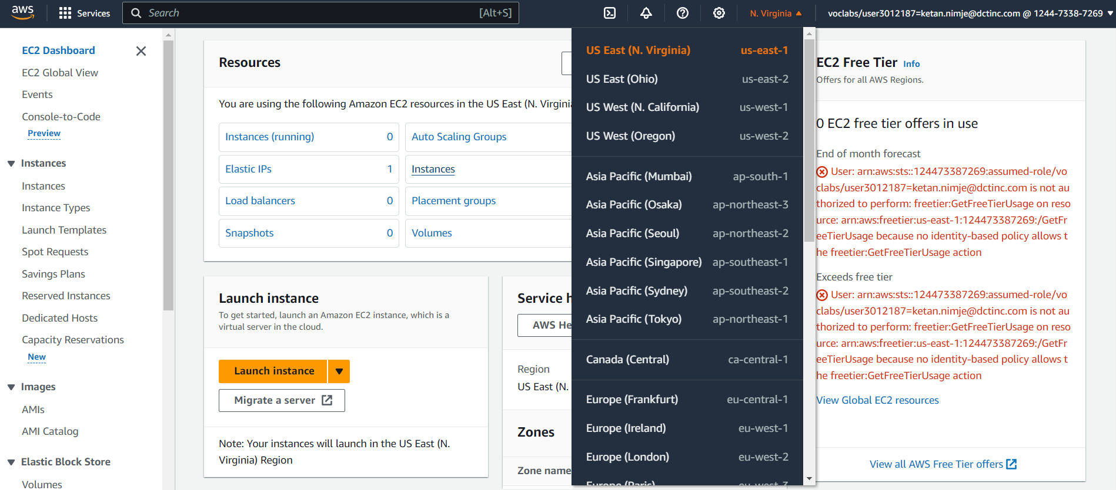

1.To understand the process of setting up and managing an Amazon EC2 instance.

Choosing the location as US East.

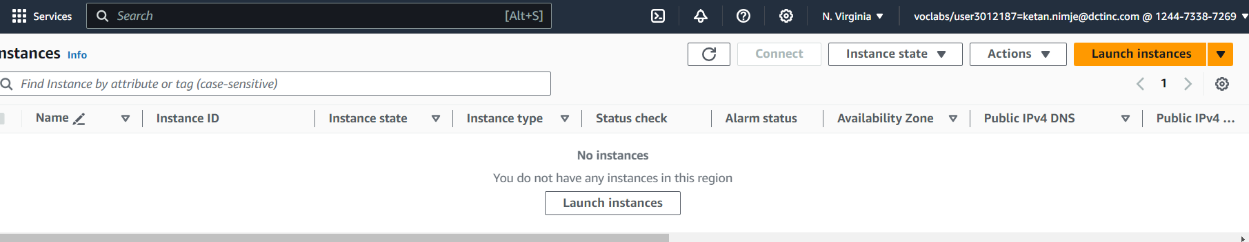

Launching the EC2 Instance

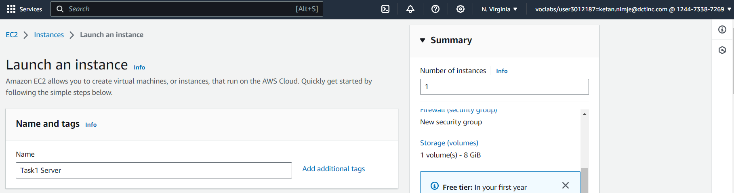

Set the instance type, instance configuration, architecture and create key pair.

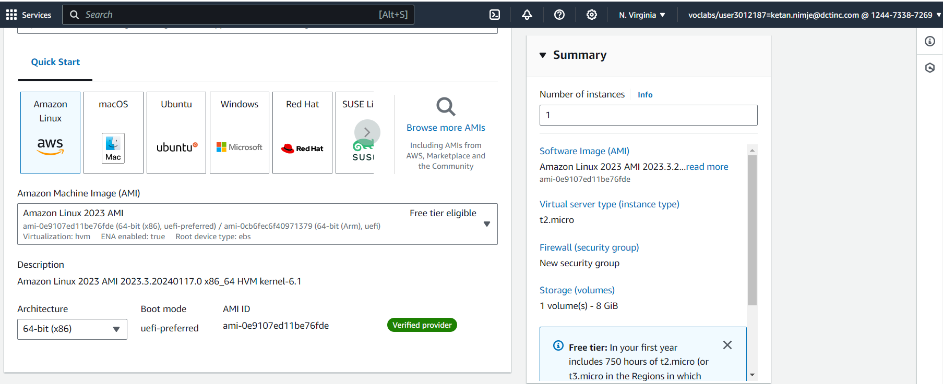

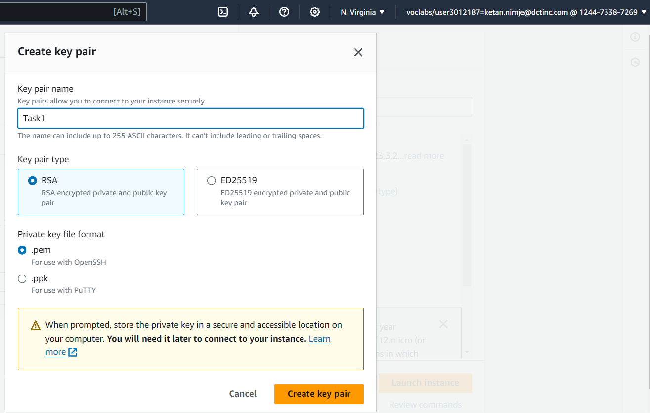

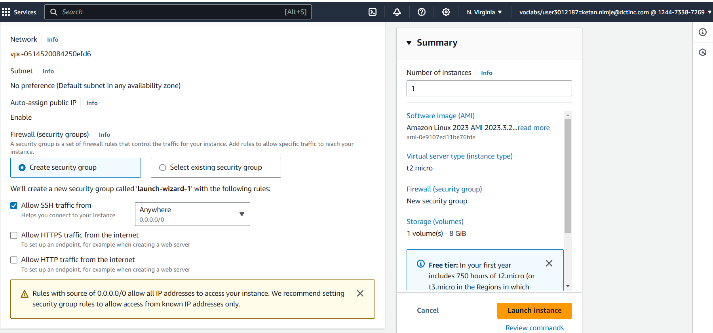

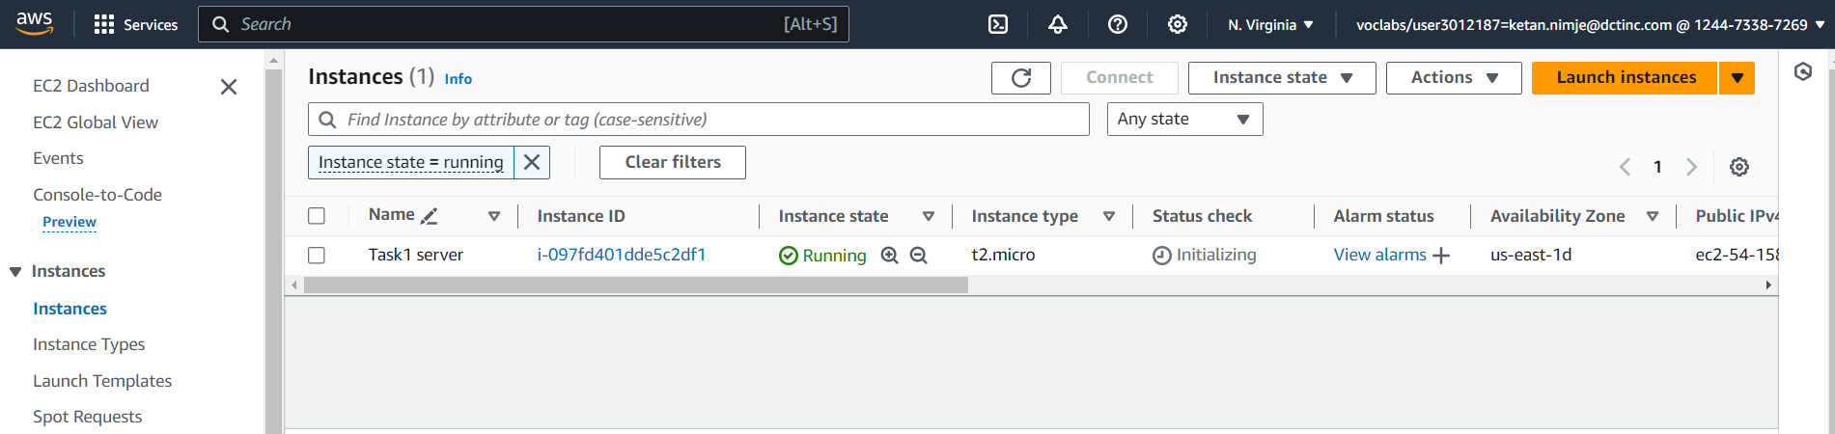

The instance is created and it is in running state.

Allocating Elastic IP and then associating it to the instance

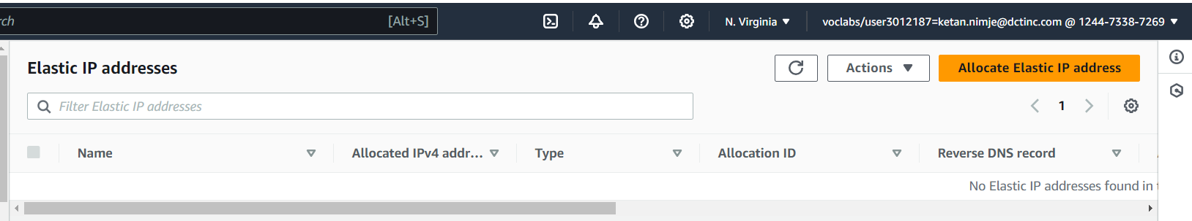

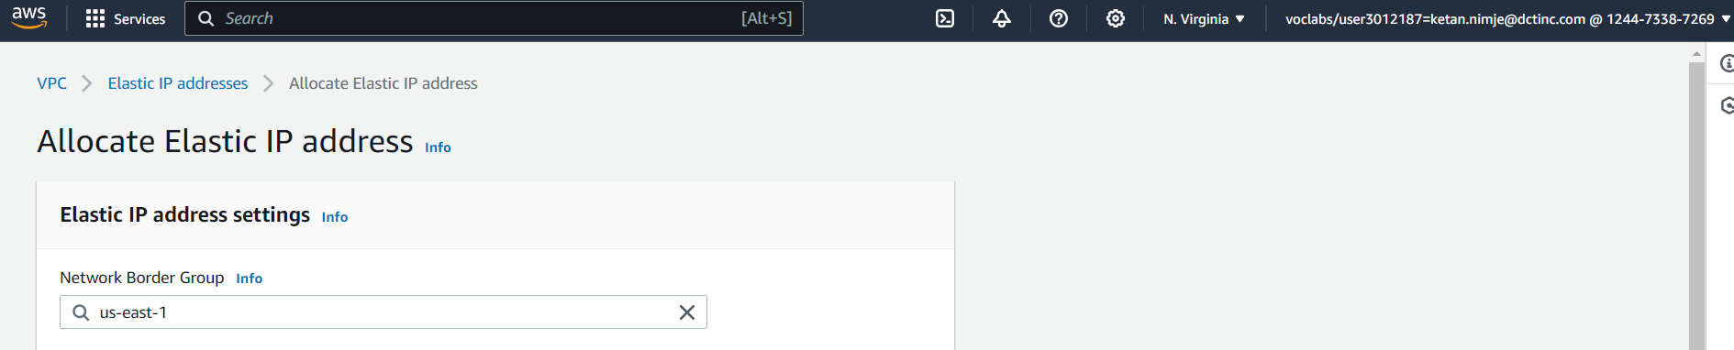

Select the network border group

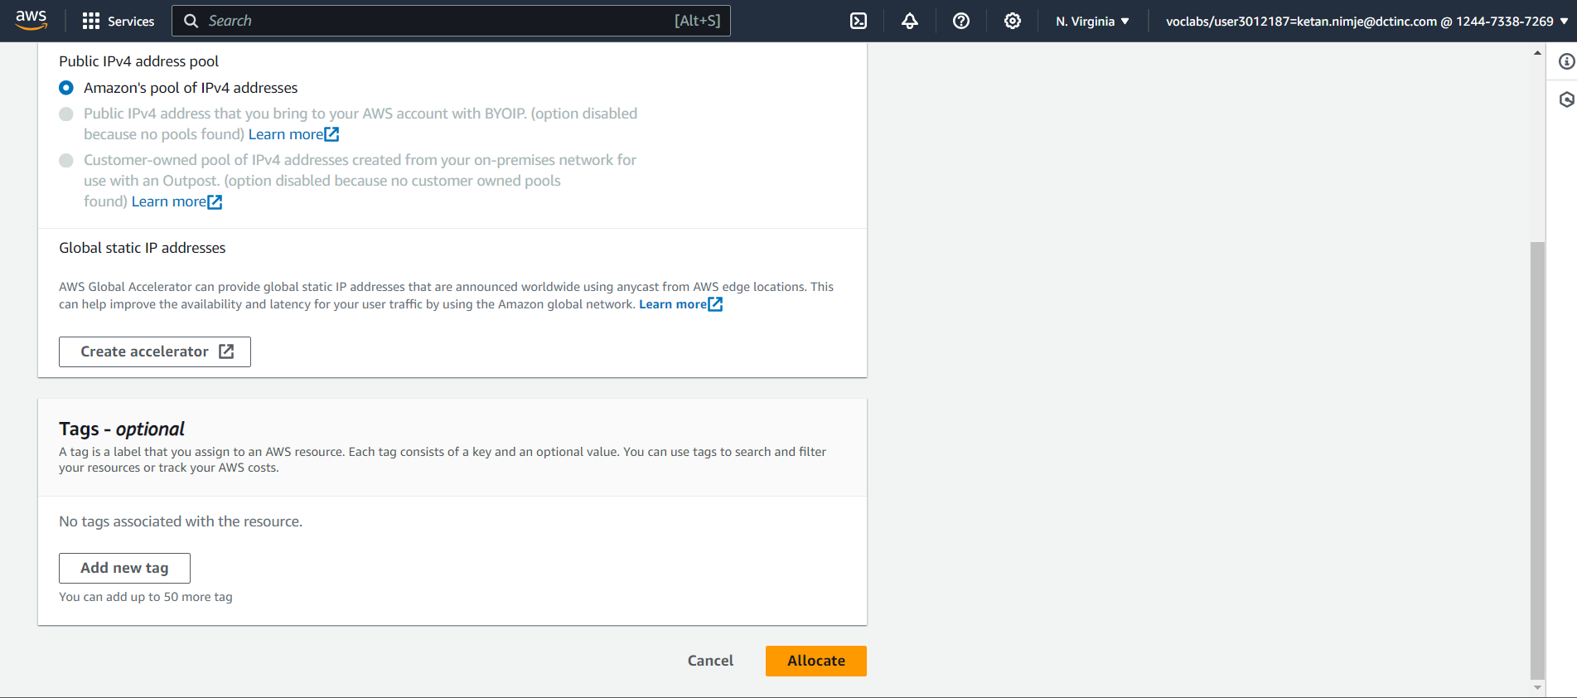

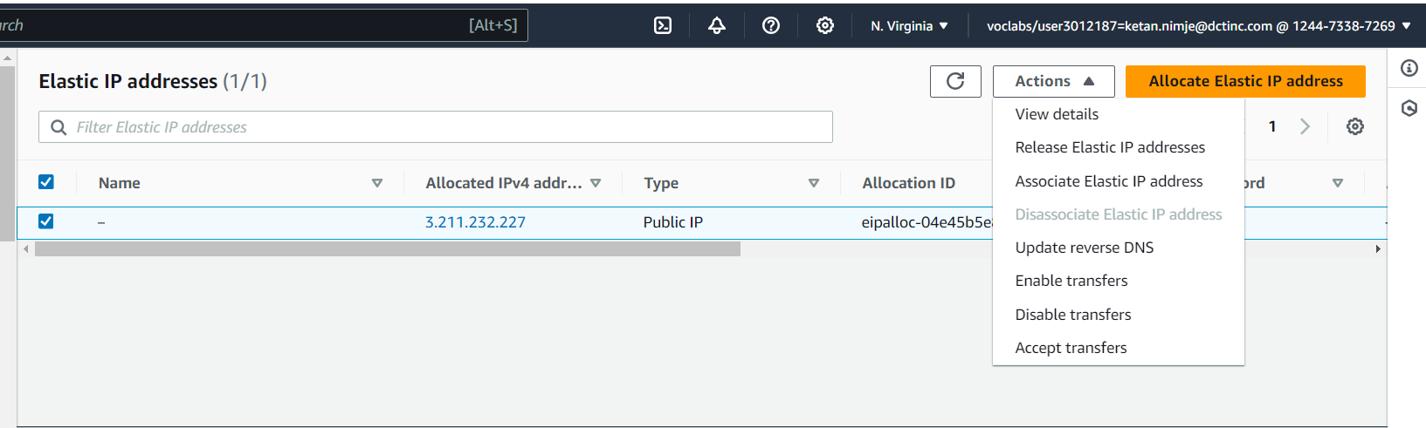

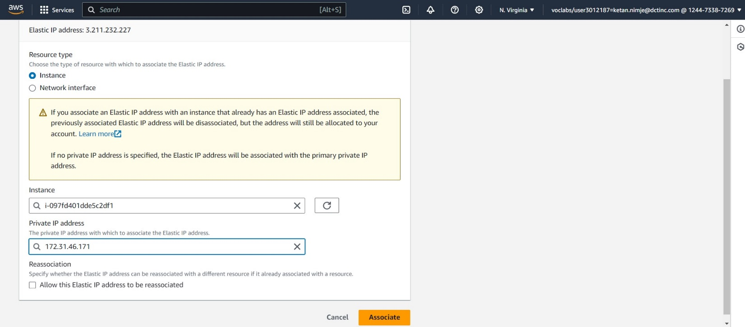

Select the resource type, instance id.

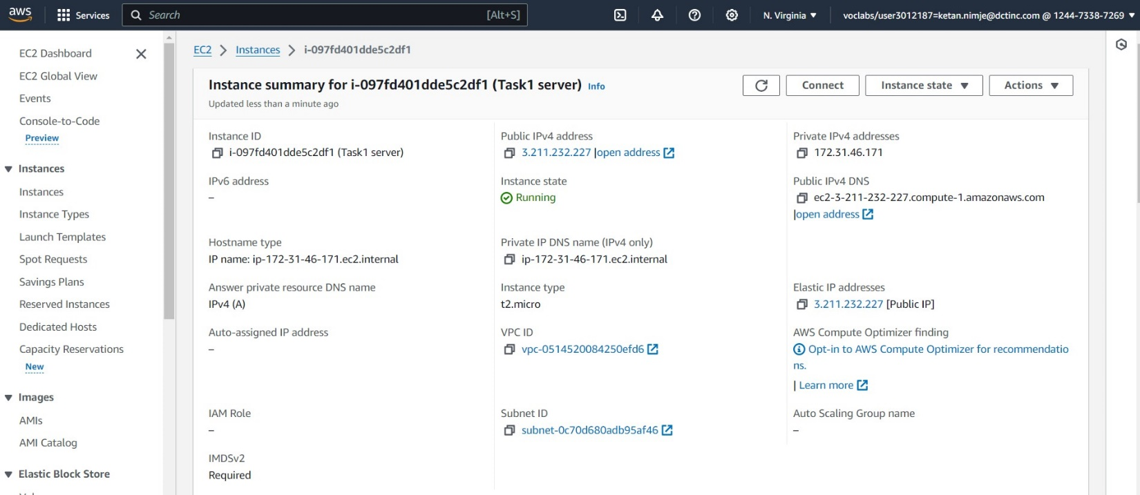

Now connecting the instance to SSH shell

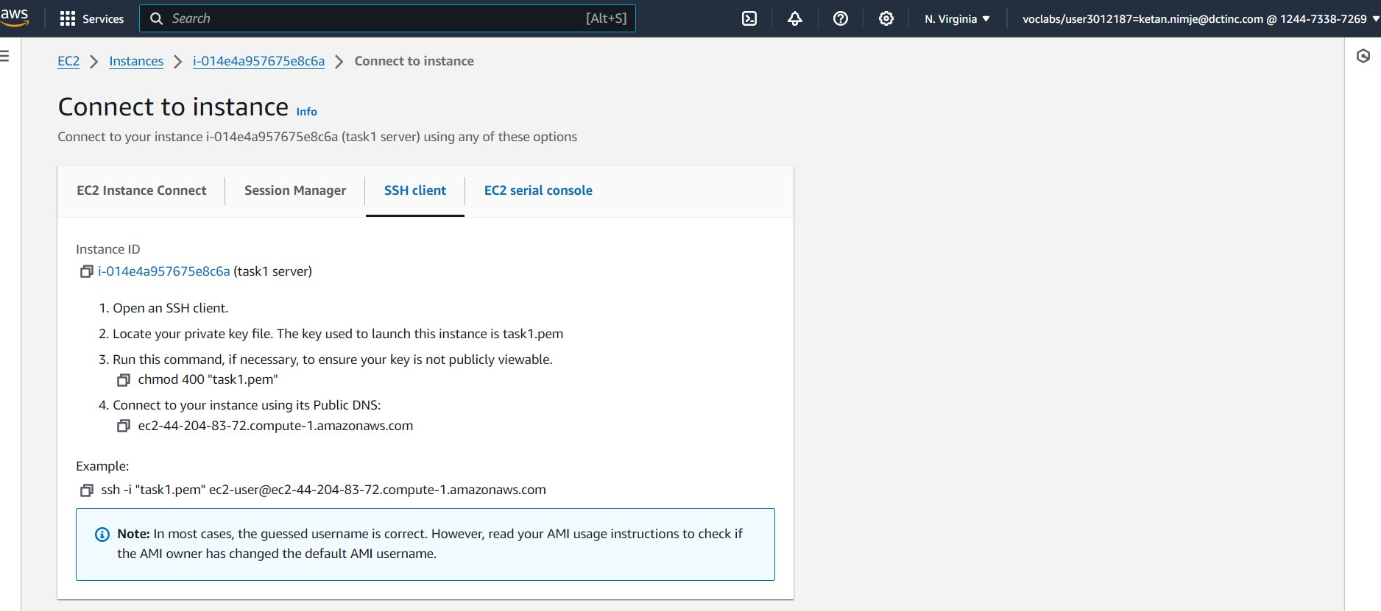

Open terminal (command prompt in windows) in the folder having key pair.

Give the command -> ssh -i <name of pem file> <username>@<IPv4 Public DNS> or copy the whole command as shown in the window above.

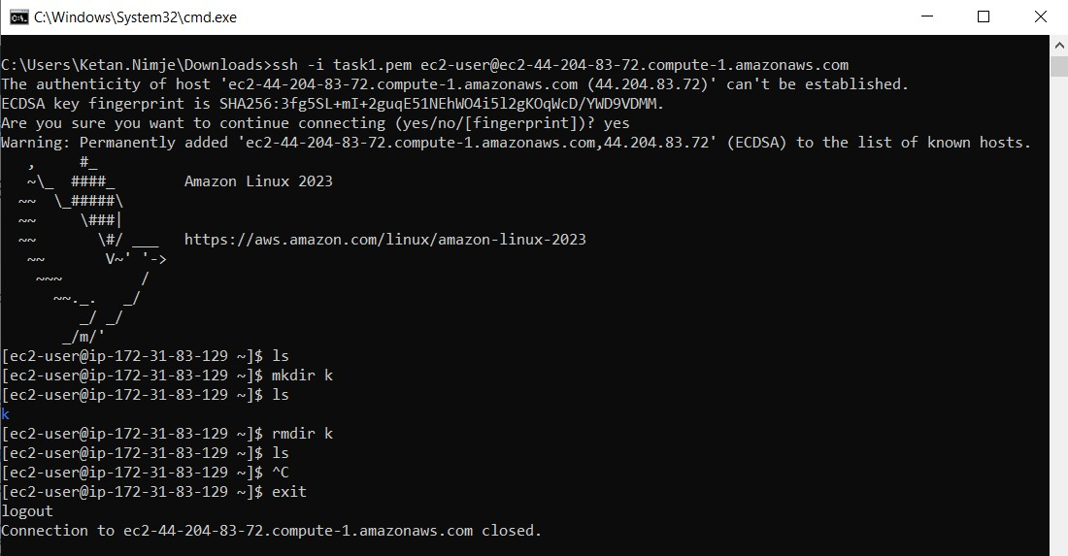

After completing the task terminating the EC2 instance in the instance state tab.

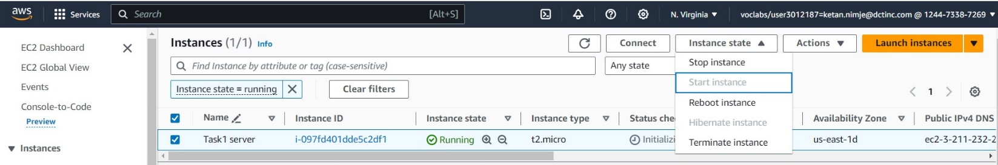

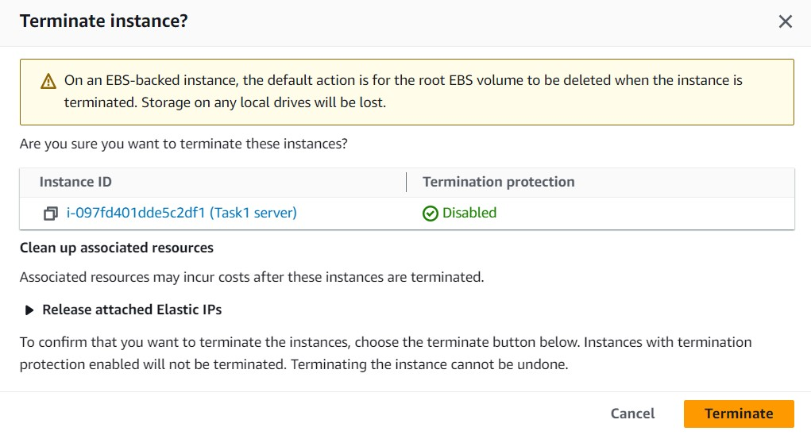

2.To gain hands-on experience with Amazon S3 by performing basic storage operations.

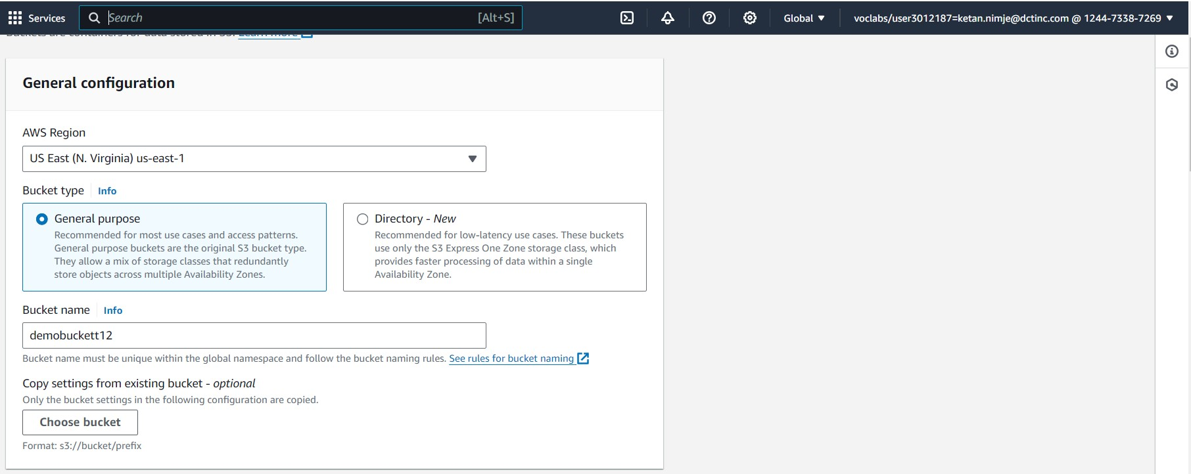

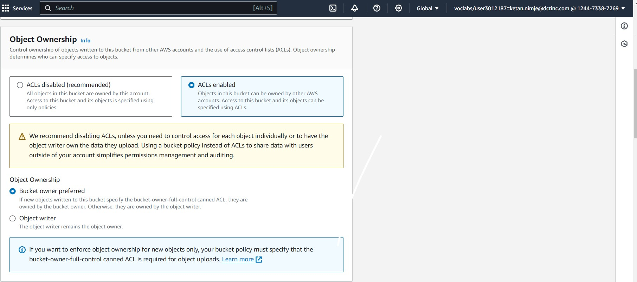

Specify the aws region, bucket type, bucket name, object ownership. Uncheck the block all public access to enable the public access to bucket.

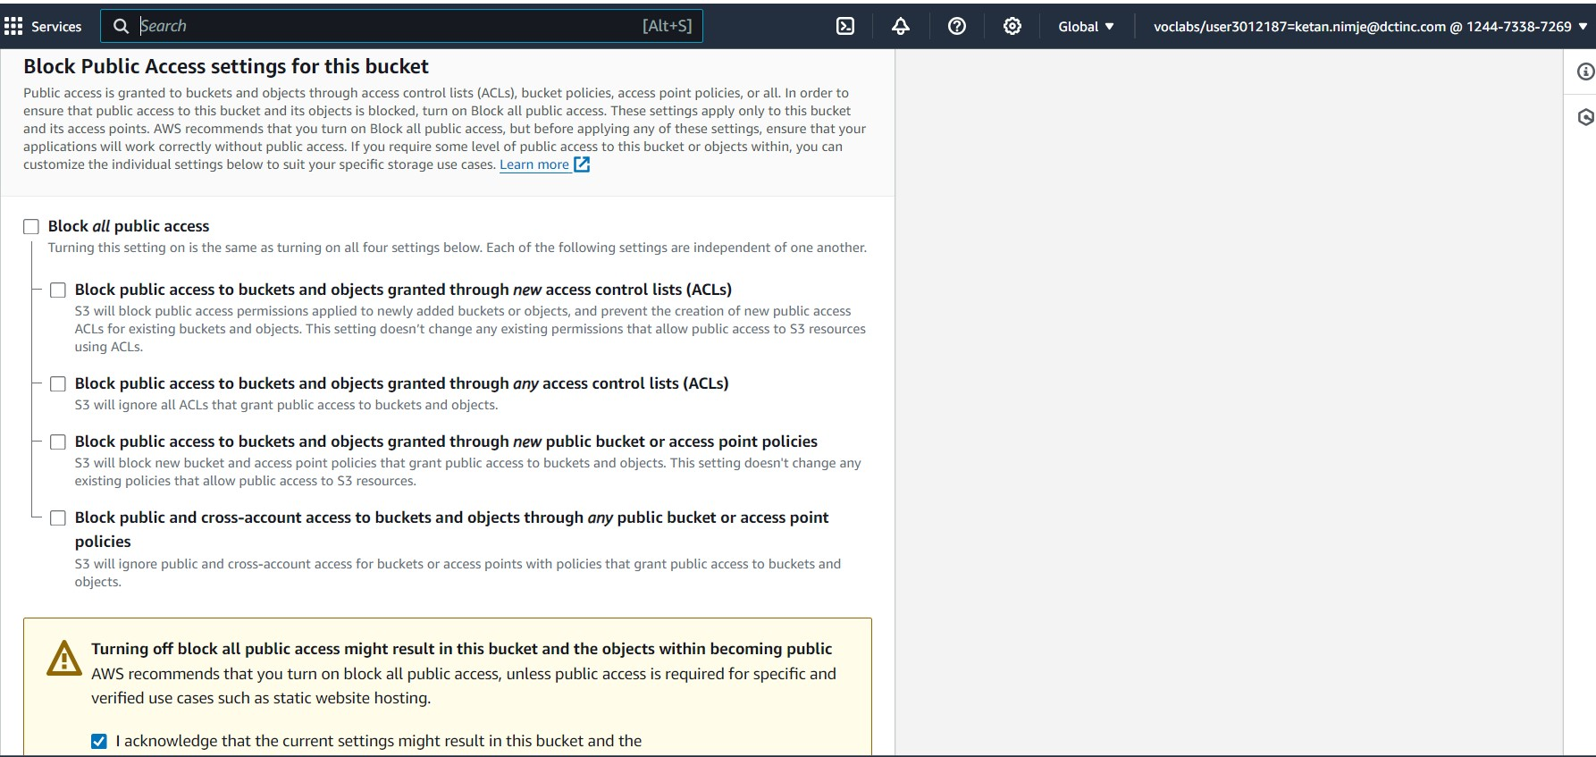

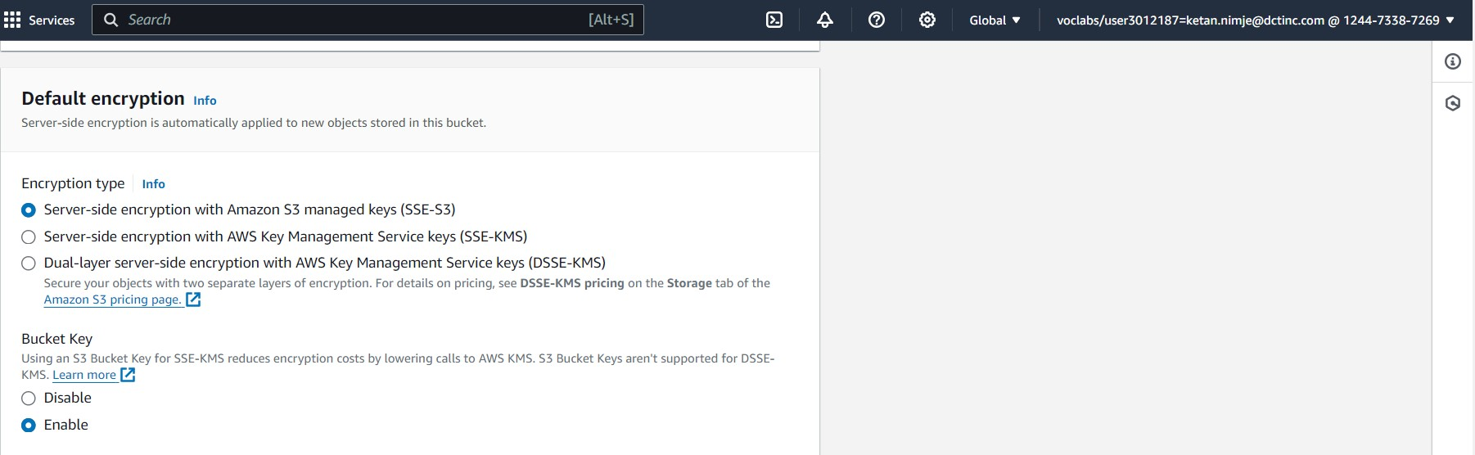

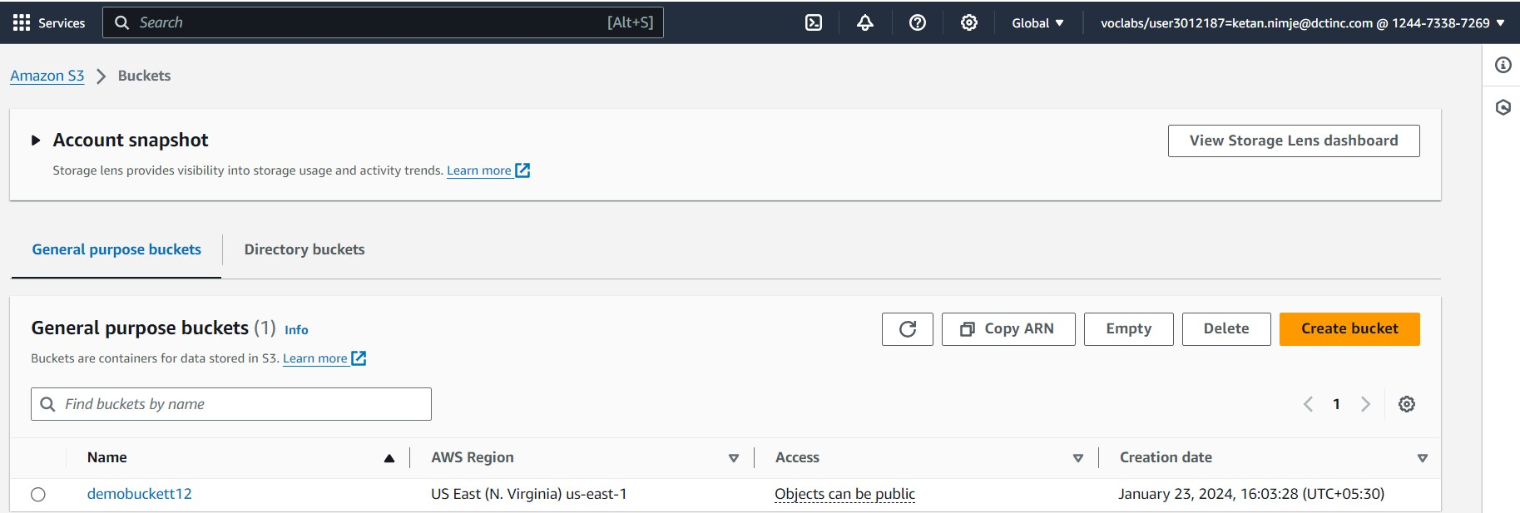

S3 Bucket is created. Now insert the file in the bucket which will be created as an object using the aws user interface.

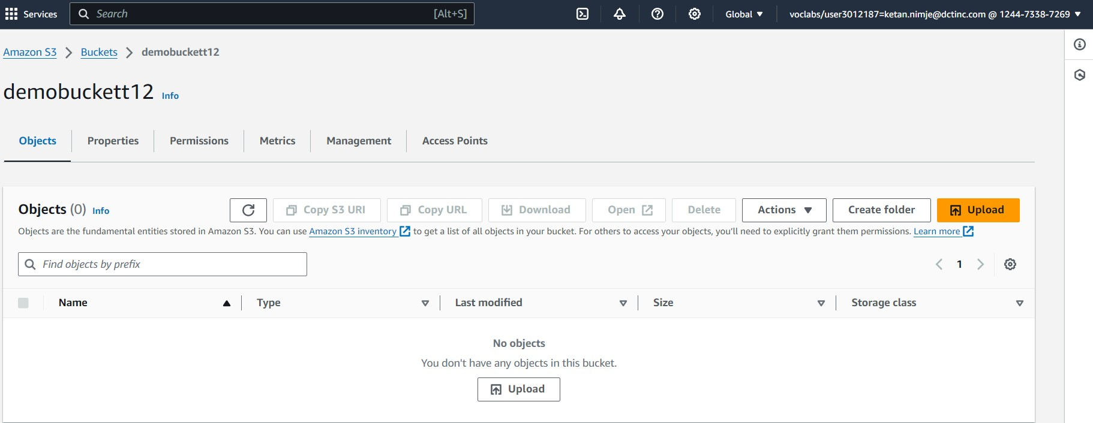

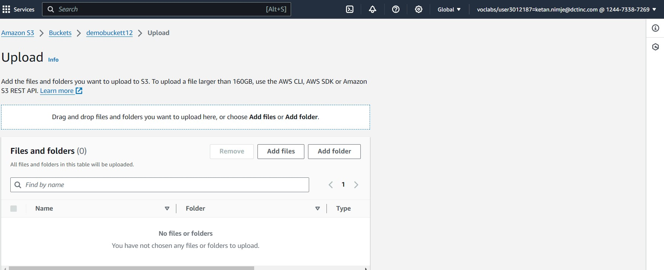

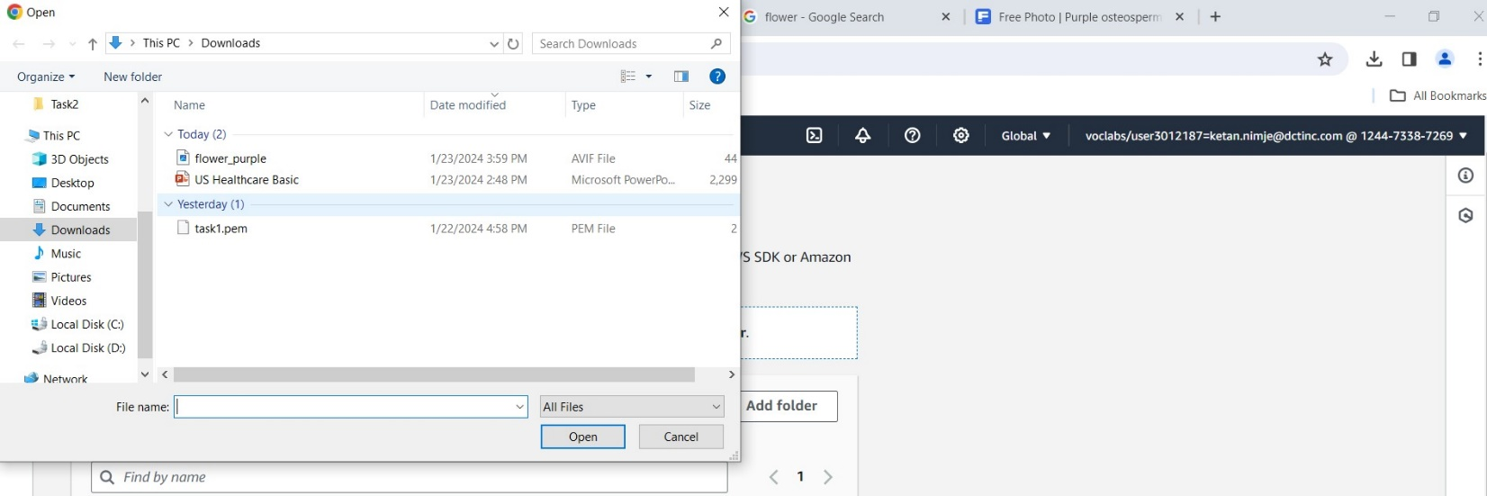

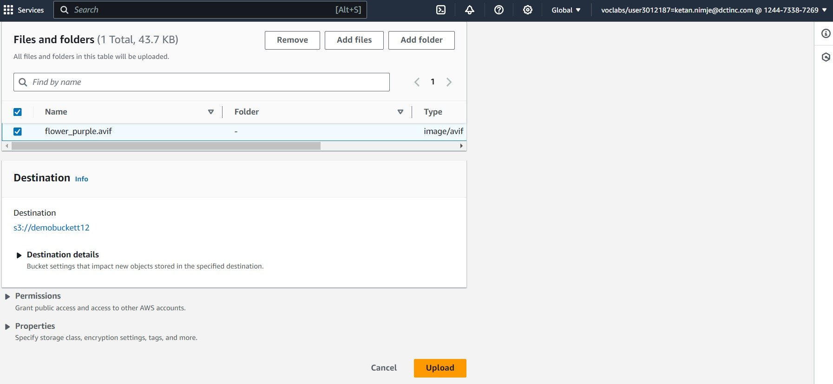

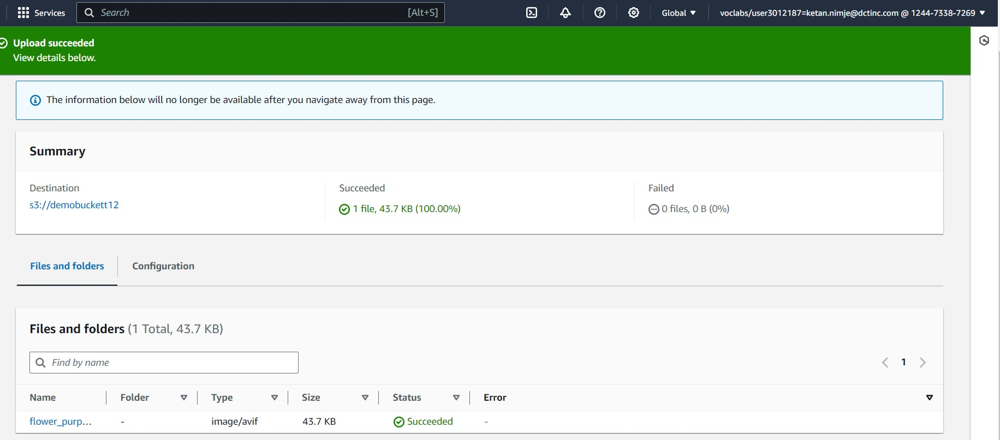

Object flower_purple is created.

After the file is uploaded as an object, make the object public to be able to access it on internet using the object URL.

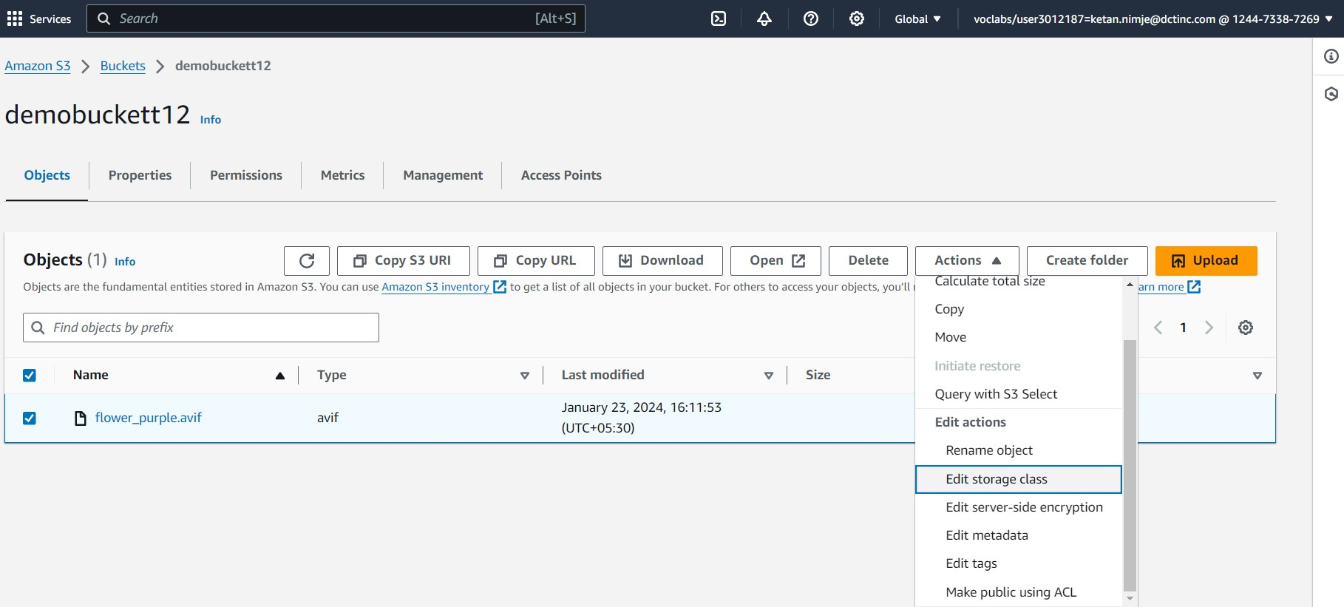

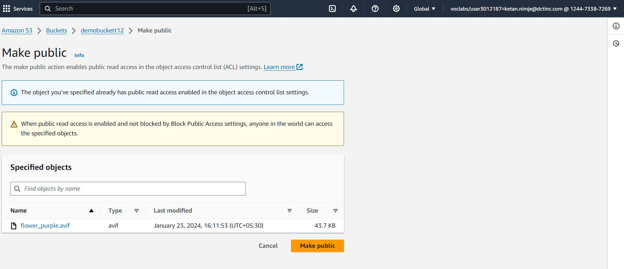

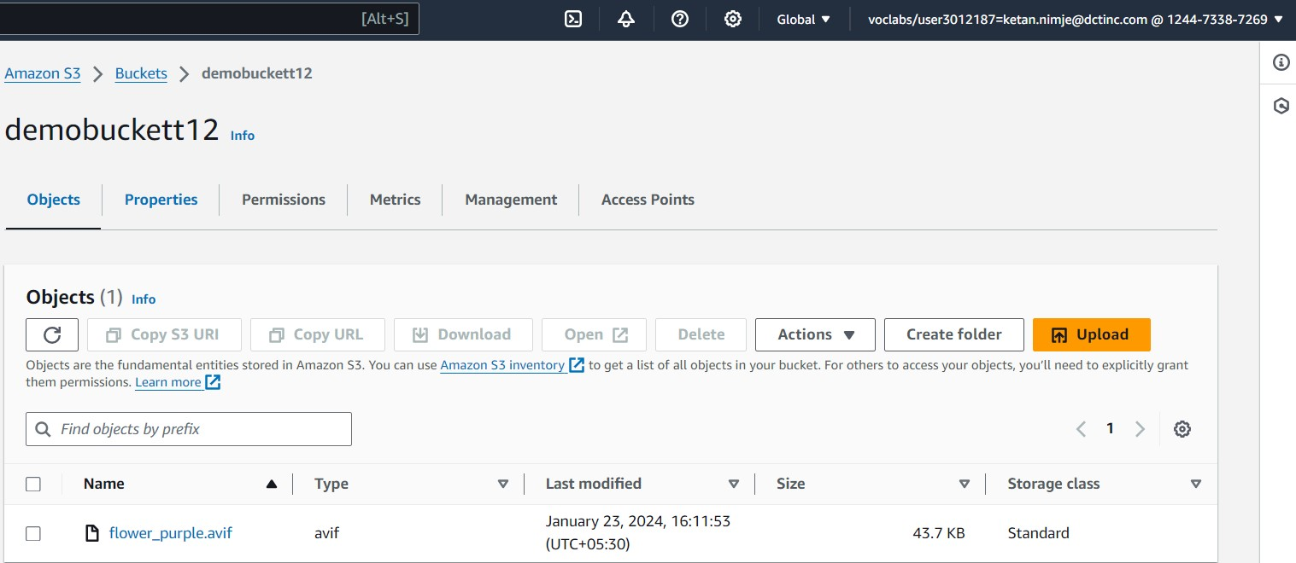

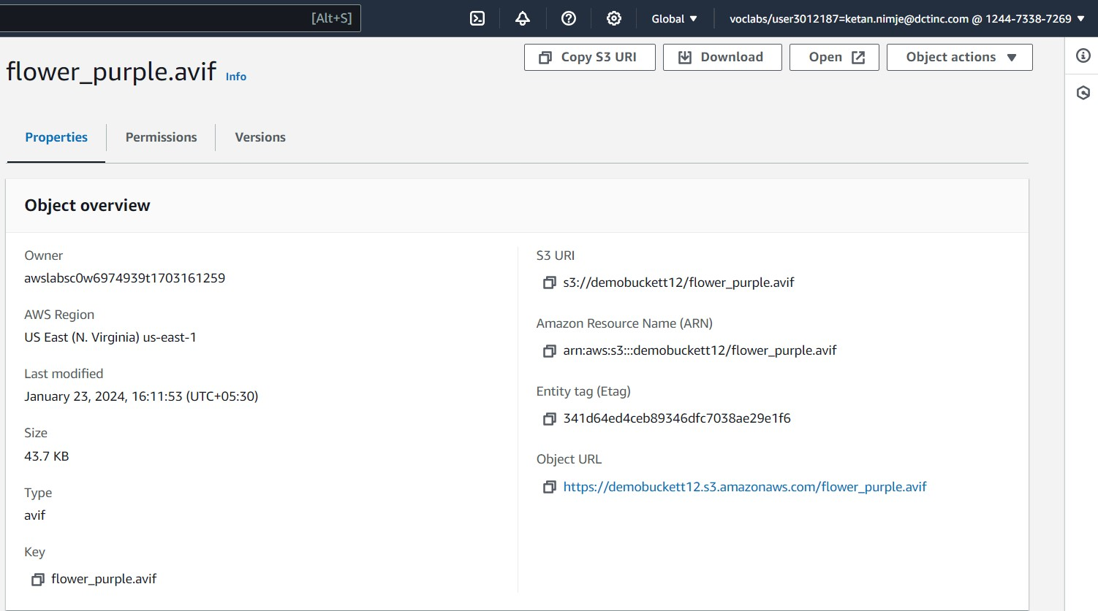

Clicking on the object URL, we will be able to access the file on internet. Below shown image is the file uploaded. Then deleting the object and the bucket using the aws user interface.

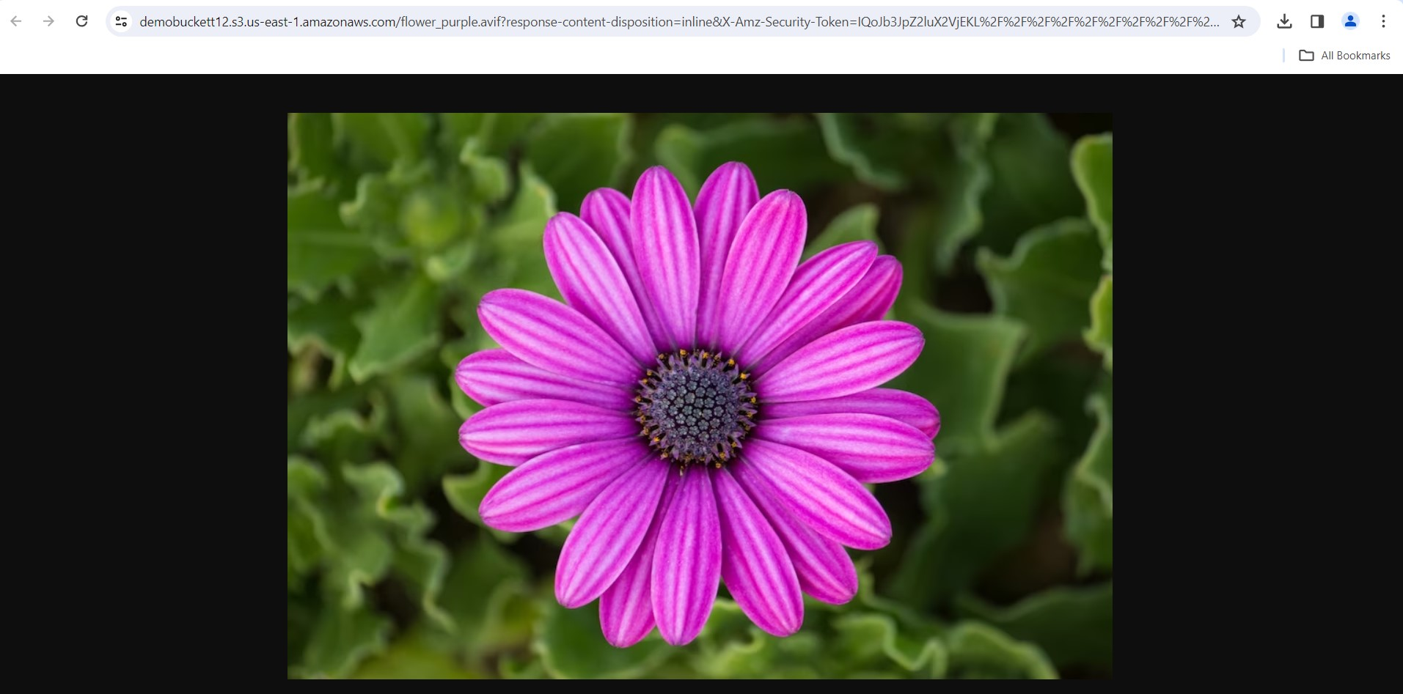

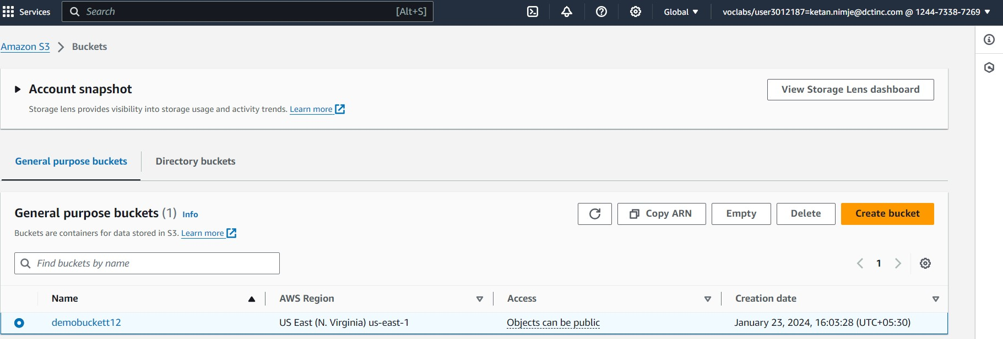

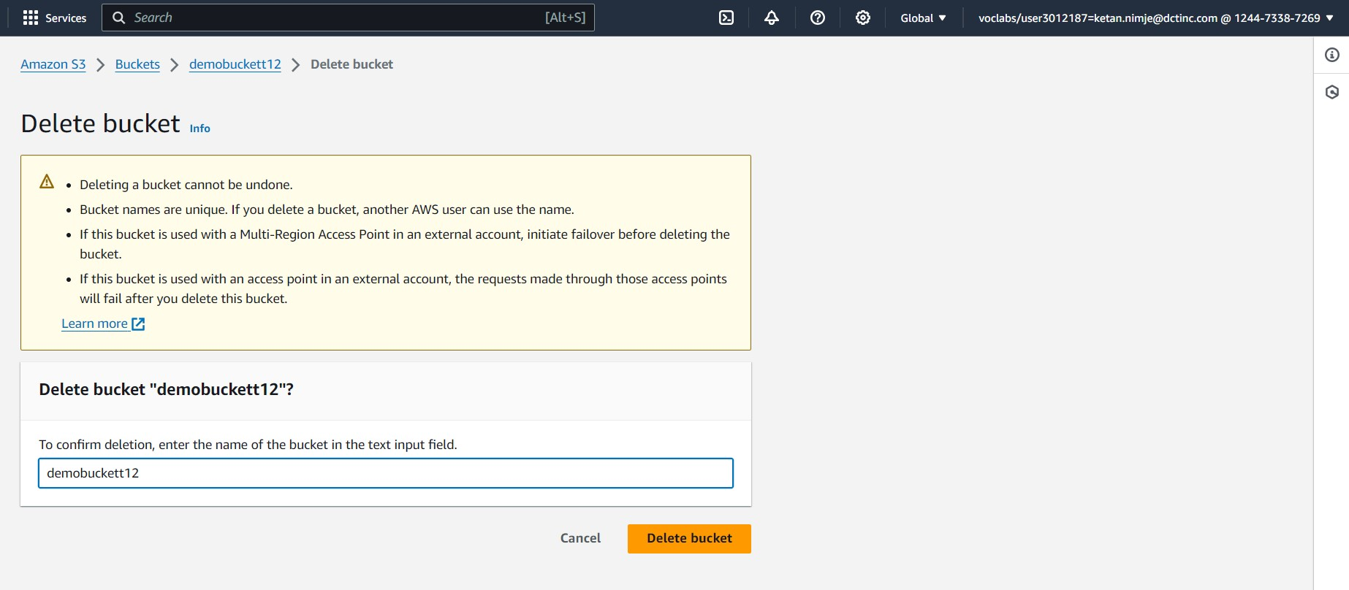

To understand the fundamentals of AWS networking through the configuration of a Virtual Private Cloud (VPC).

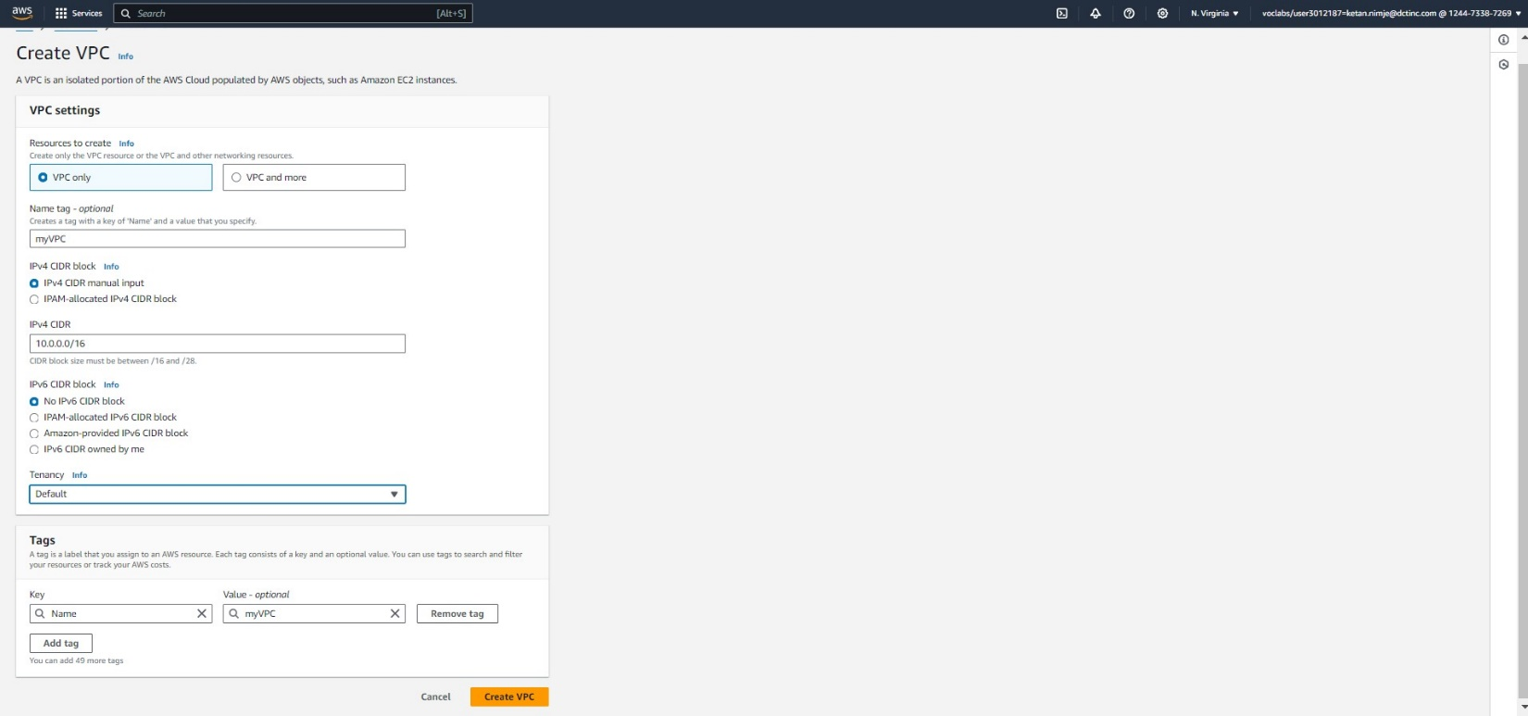

Creating vpc, specifying IPv4 block, tenancy and then creating public and private subnet

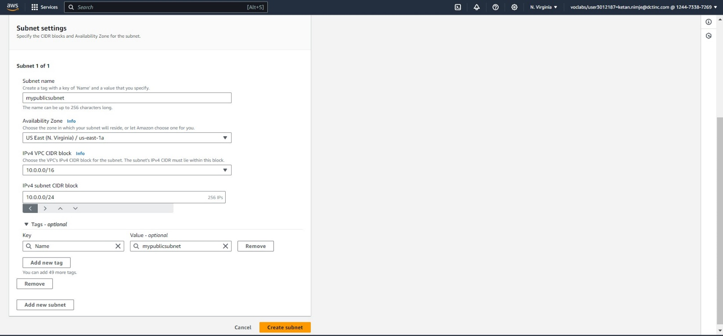

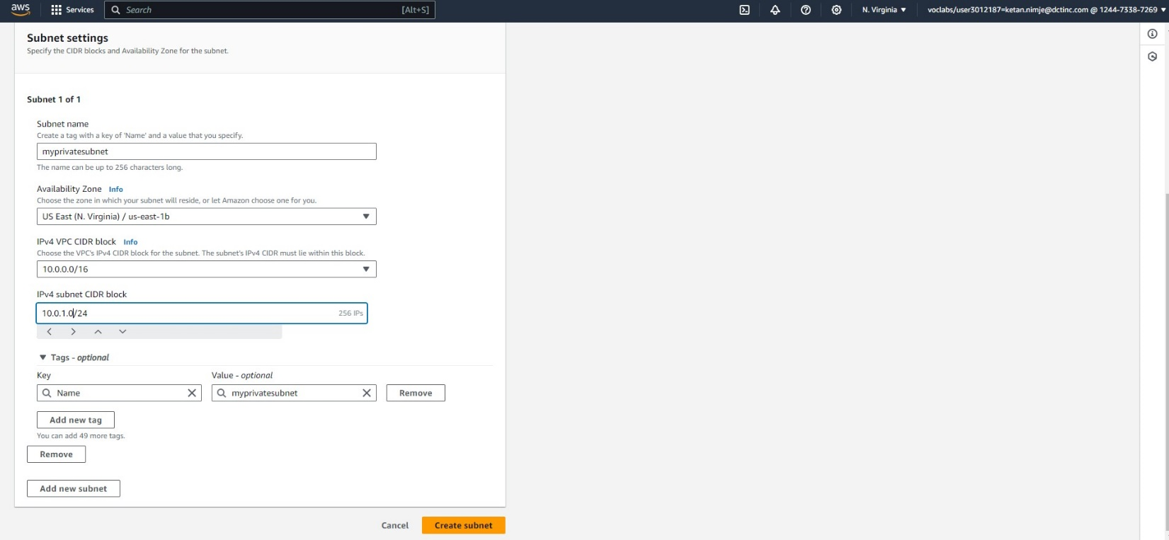

Specifying the subnet name, availability zones, IPv4 VPC block, IPv4 subnet block

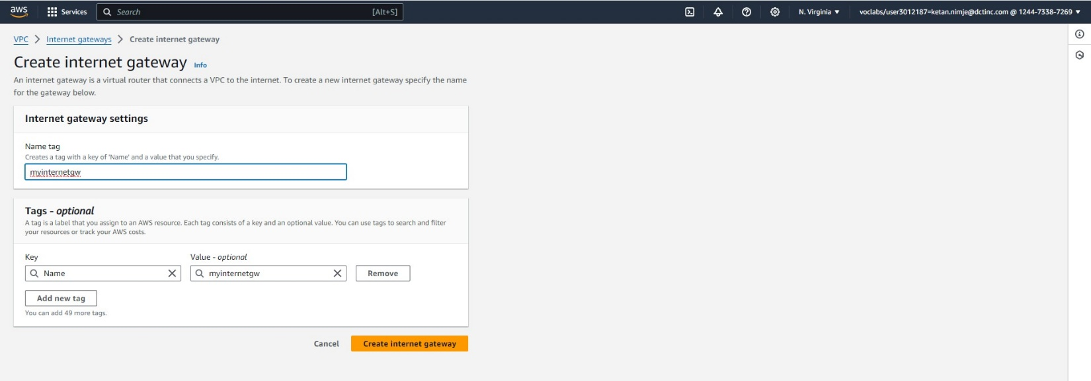

Creating Internet Gateways, giving the name tag

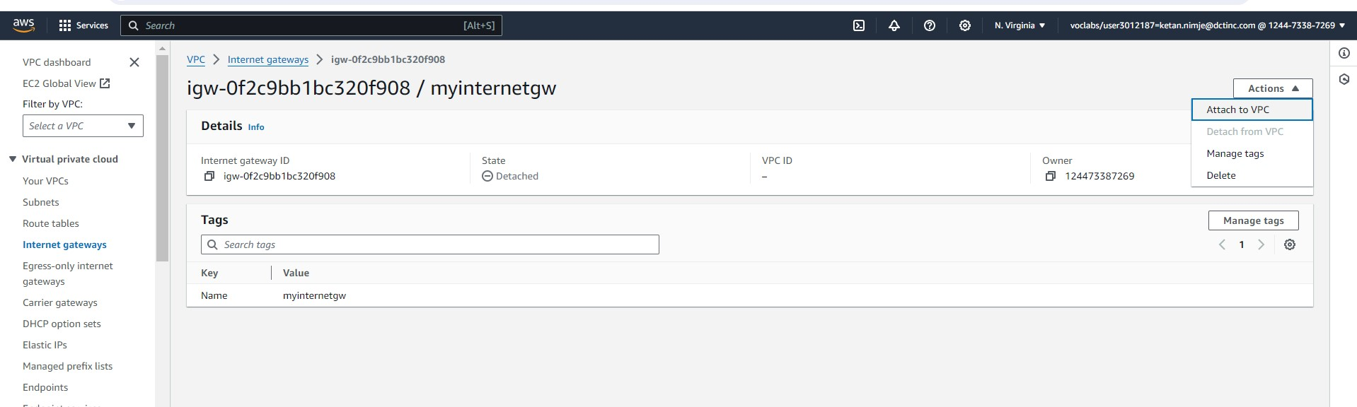

This is the created internet gateway and then we are attaching it to the VPC

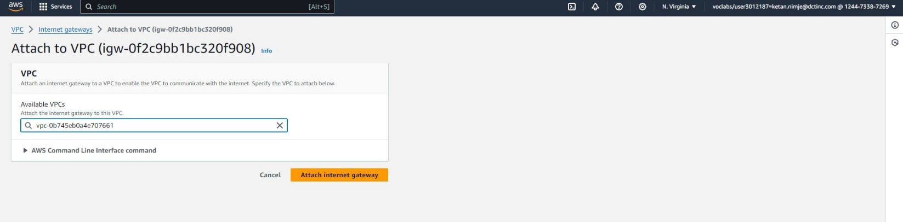

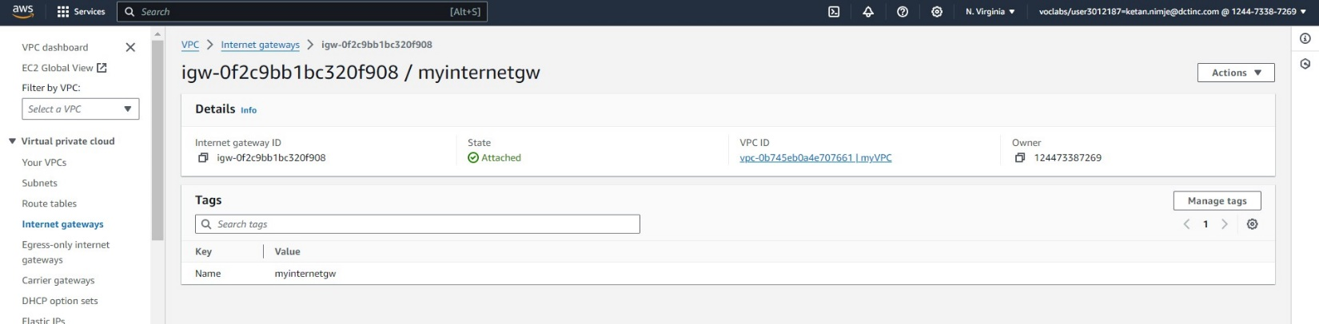

You can see in this image the status of internet gateway is attached.

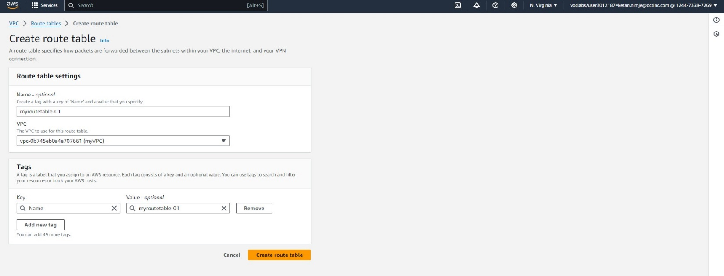

Creating Route Table, giving the name to route and then editing subnet associations in the edit subnet associations option

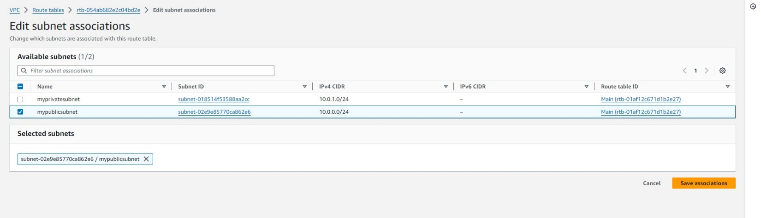

In the edit routes window, specify the internet gateway.

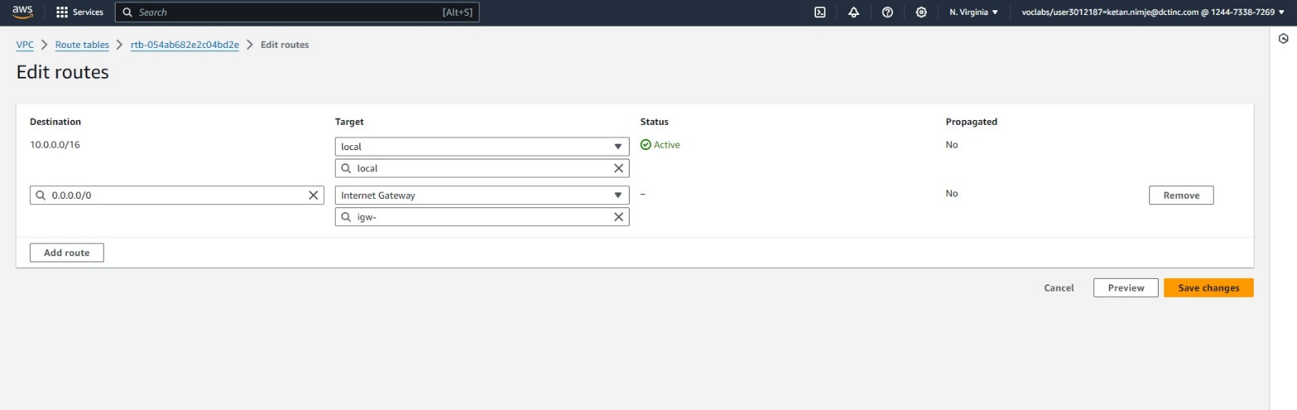

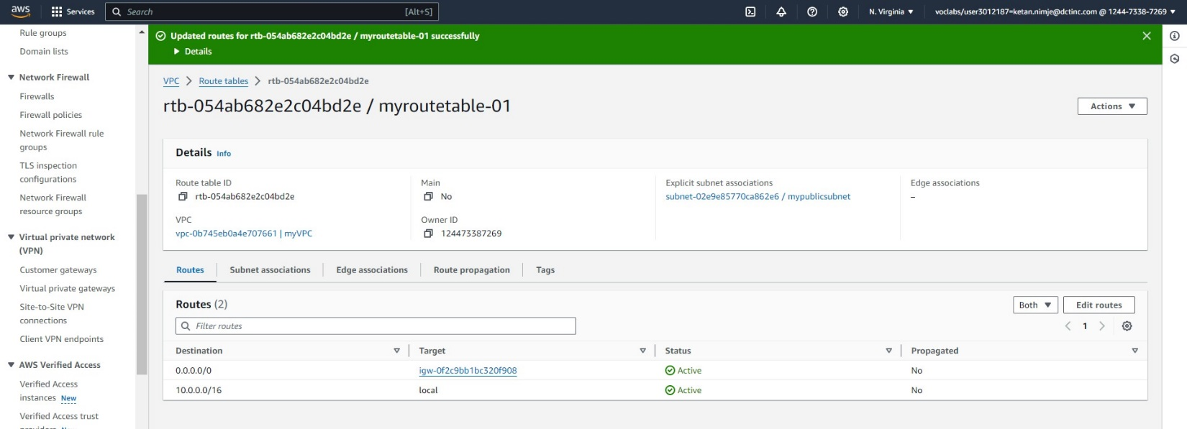

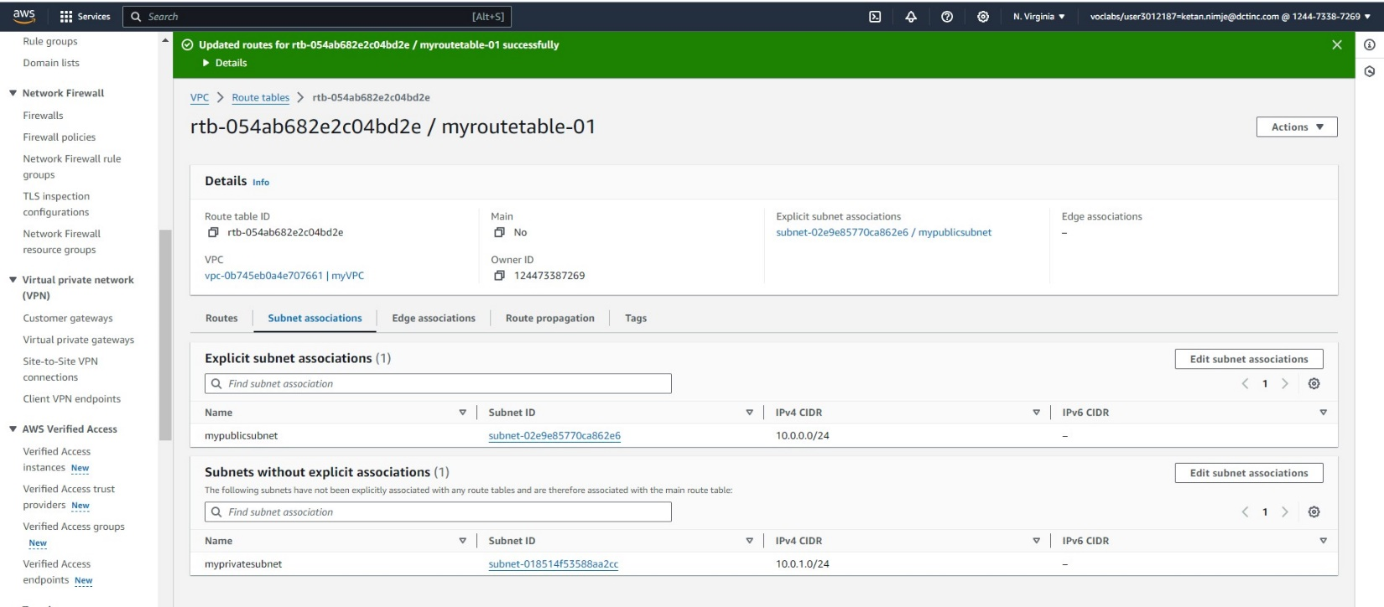

The internet gateway is in the route table as you can see as well as public subnet has been associated with the route table

Creating and launching the EC2 instance as linux web server.

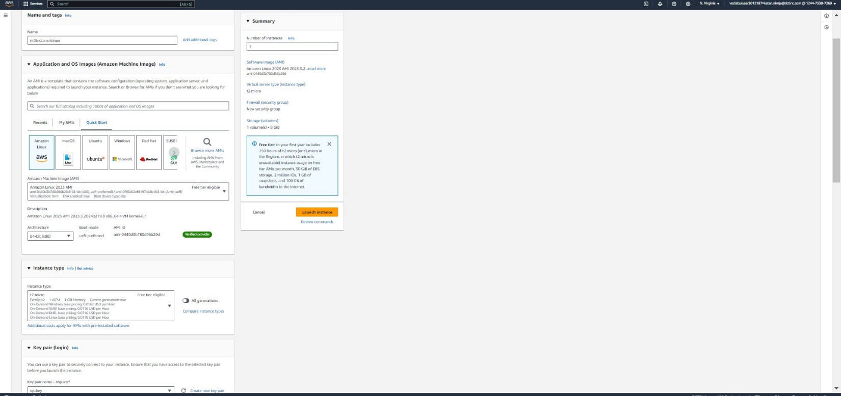

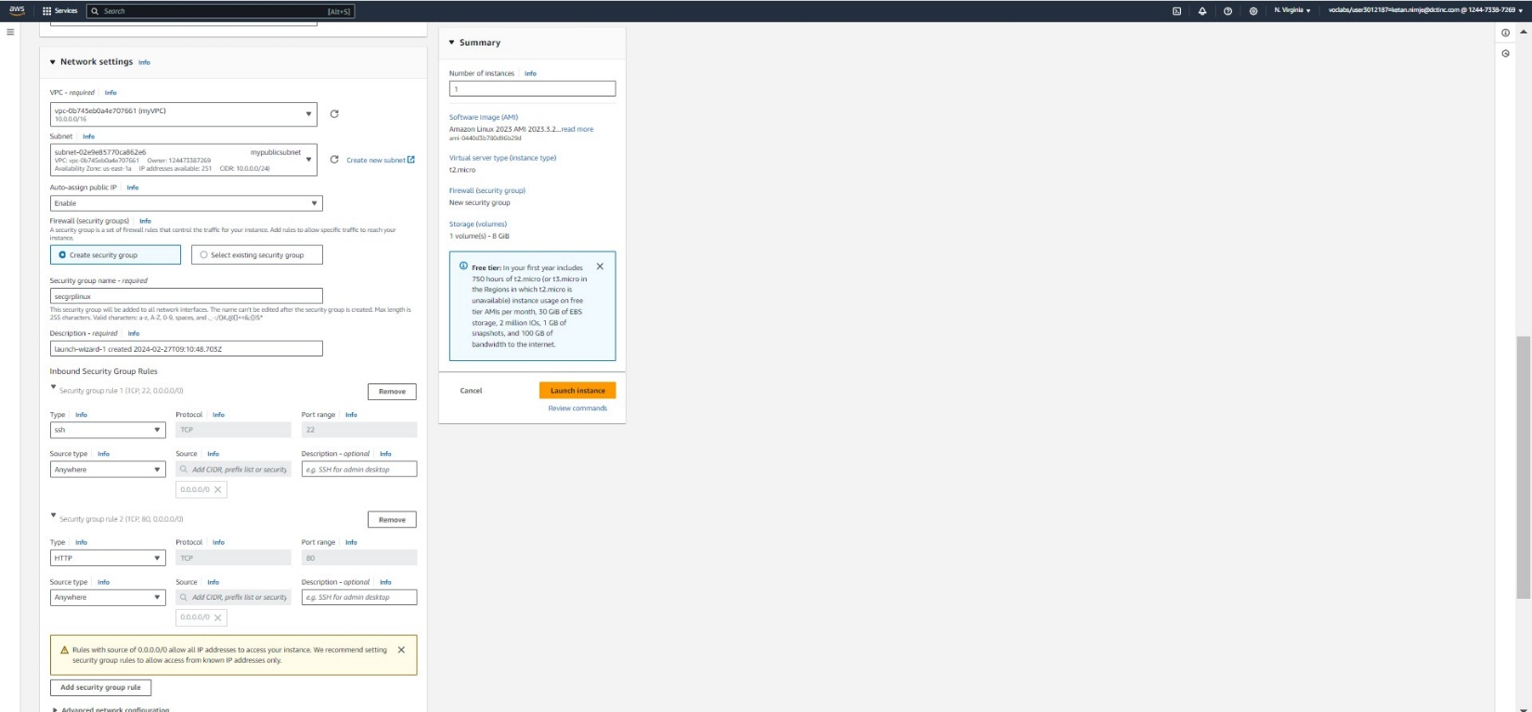

In the network settings providing newly created VPC, then public subnet, creating a new security group with newly created inbound rules, one as ssh and one as http. Launching the instance

Connecting to the instance using EC2 instance connect.

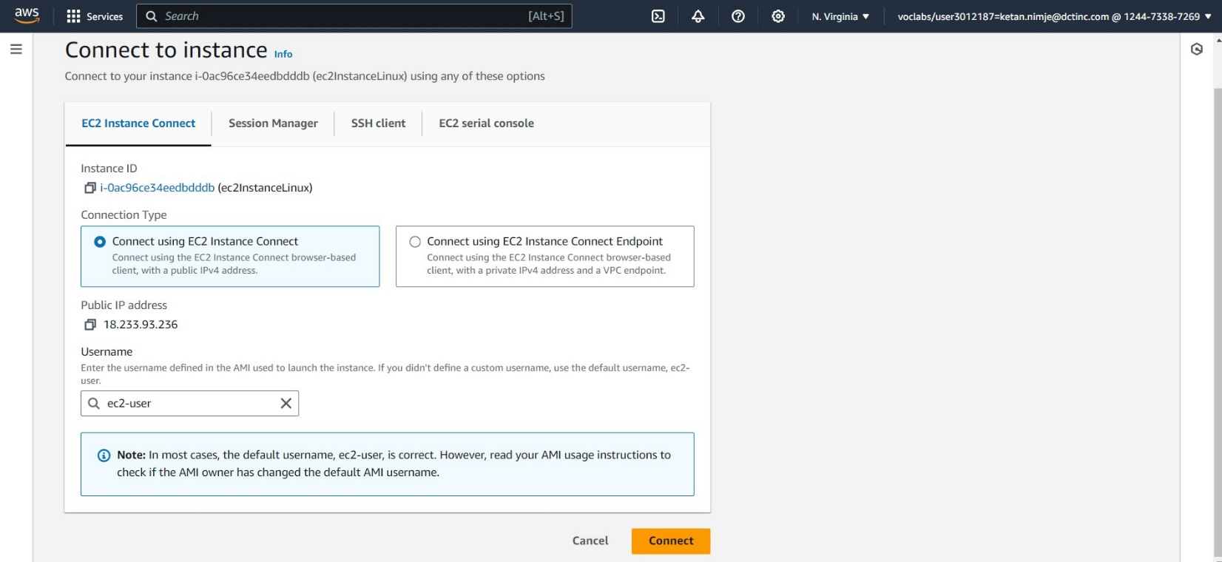

In our aws instance, creating a web server using apache web server. For that giving the following commands

sudo su  
yum update -y  
yum install httpd

systemctl start httpd  
systemctl enable httpd

And then give the commands as shown in the photo and give path as in own local machine.

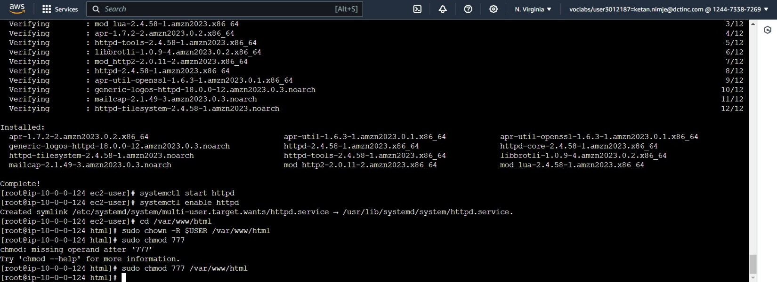

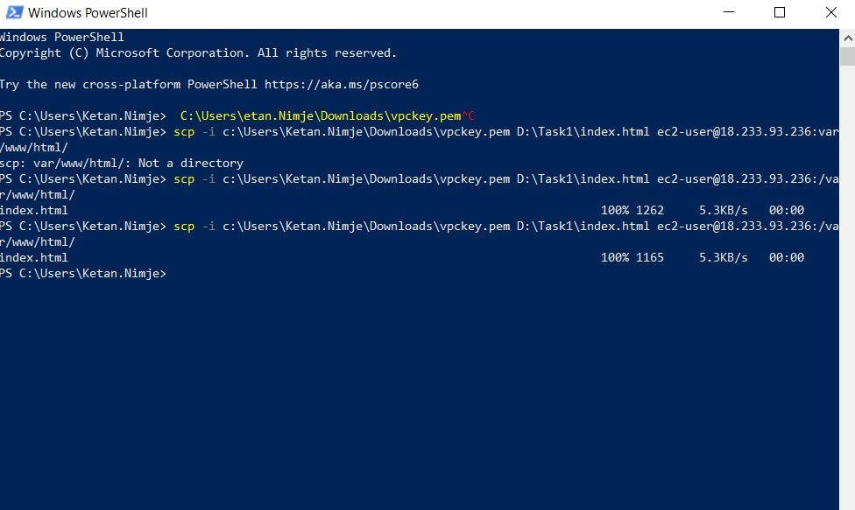

Using the above command we have uploaded html file on web server and now we can access it via our instance.

In the above command, First part Is for pem file and then the html file which to be uploaded on web server.

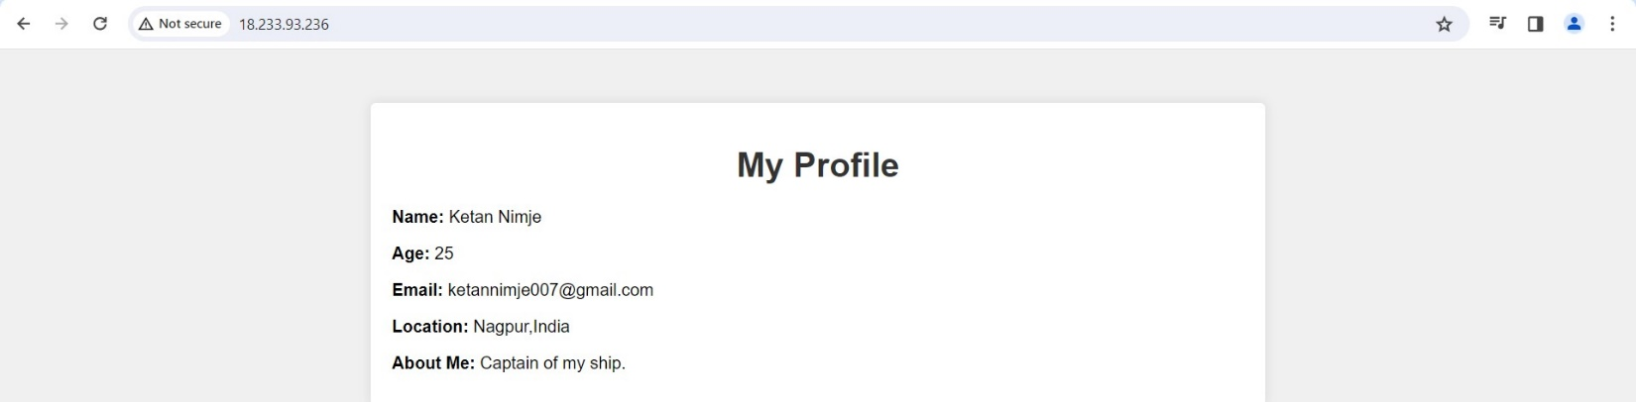

Create a windows EC2 instance

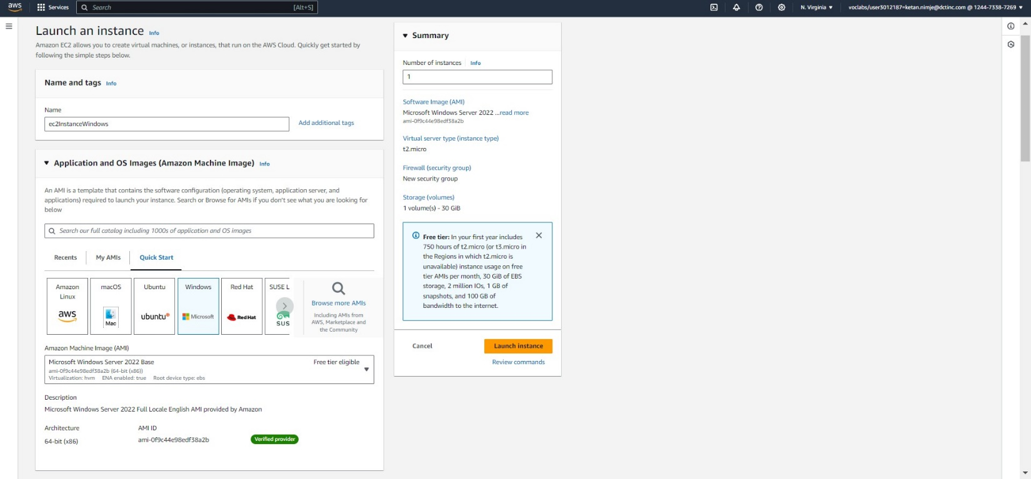

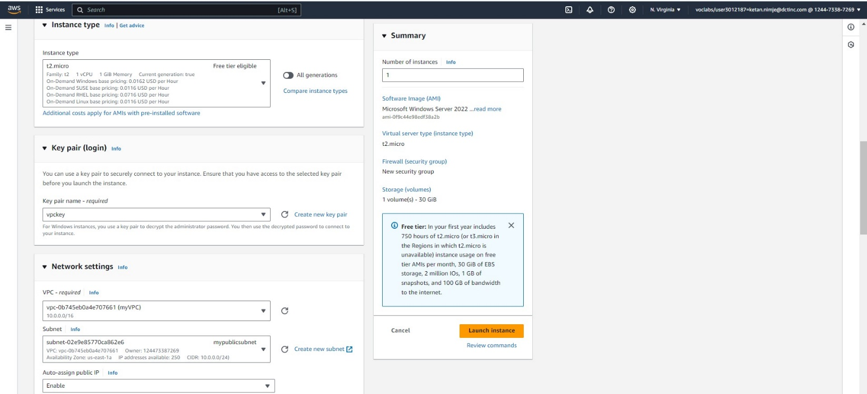

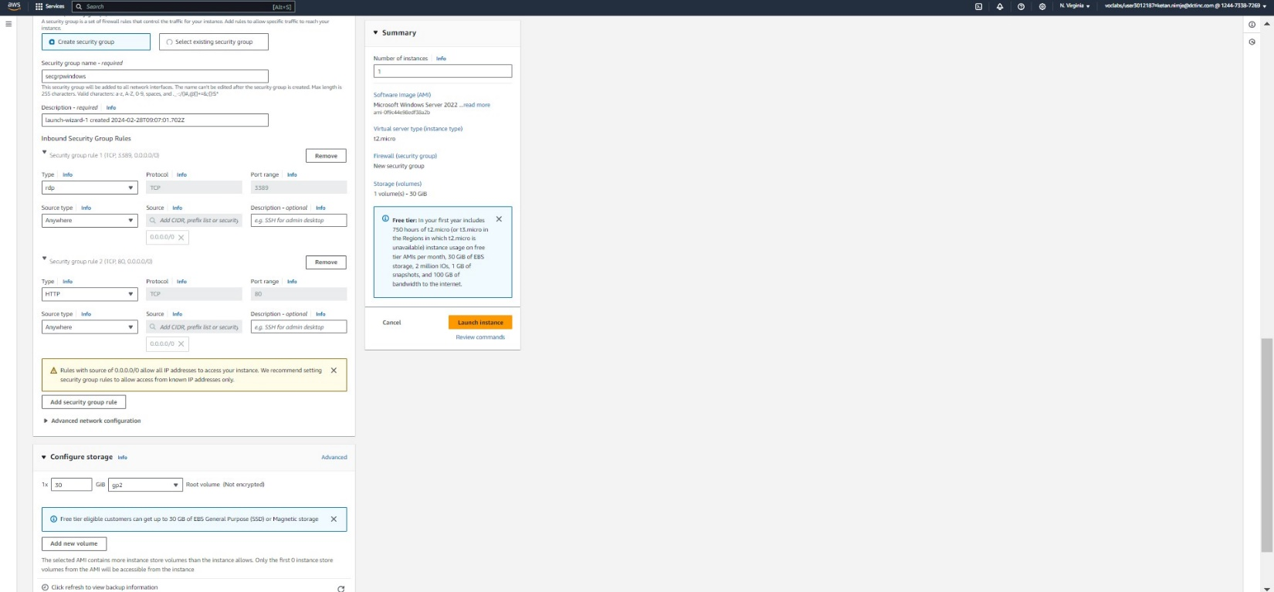

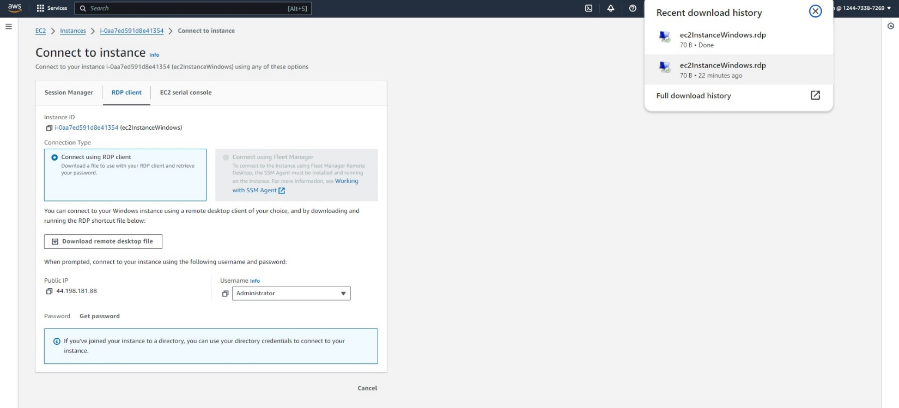

Connect to the instance using RDP client and download remote desktop file.

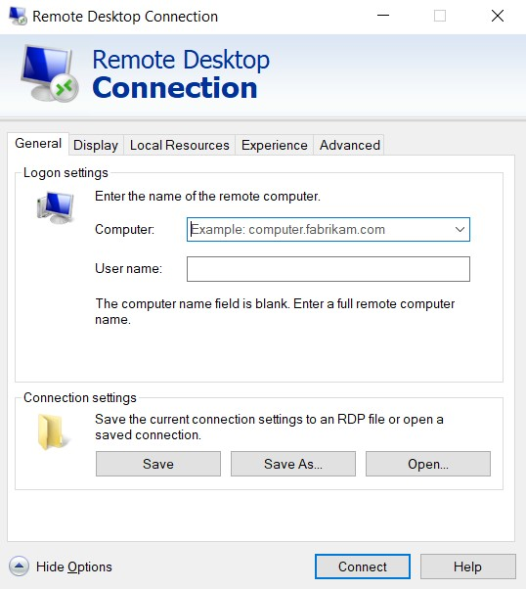

Now in local machine open remote desktop connection. And add the folder or drive which you want to have as shared resource in your local machine as well as VM.

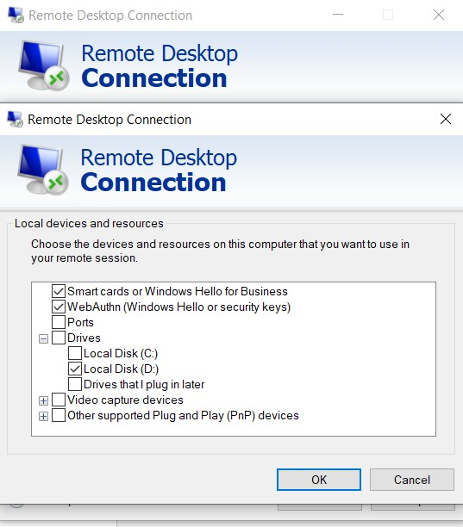

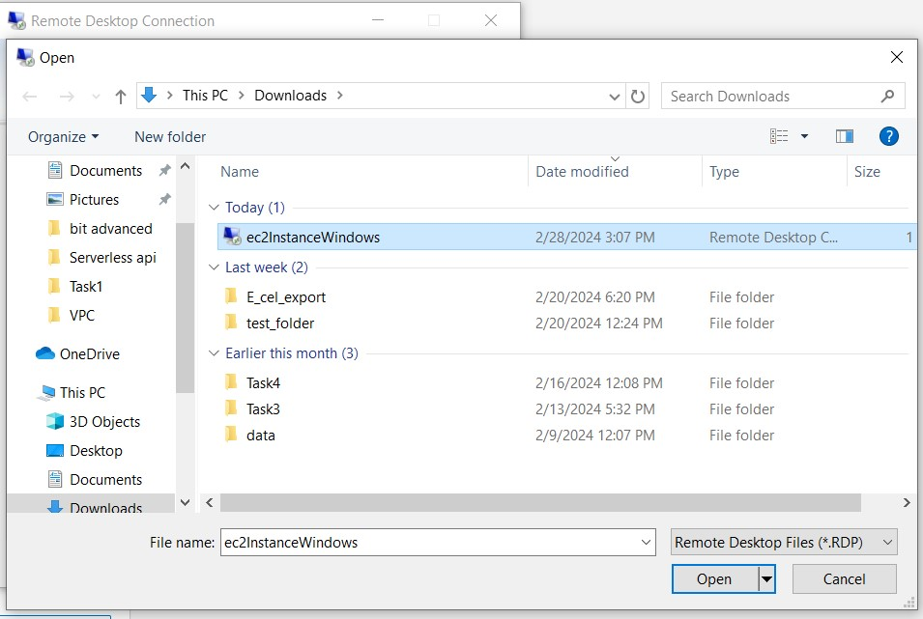

And finally open the downloaded remote desktop file and connect to the virtual machine.

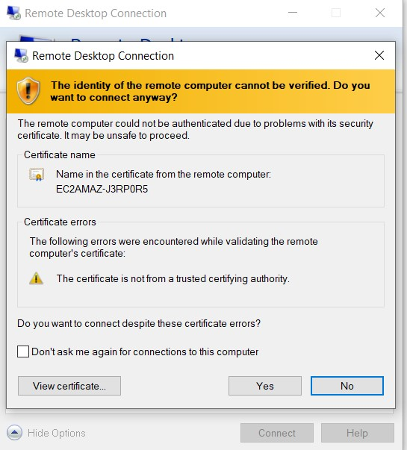

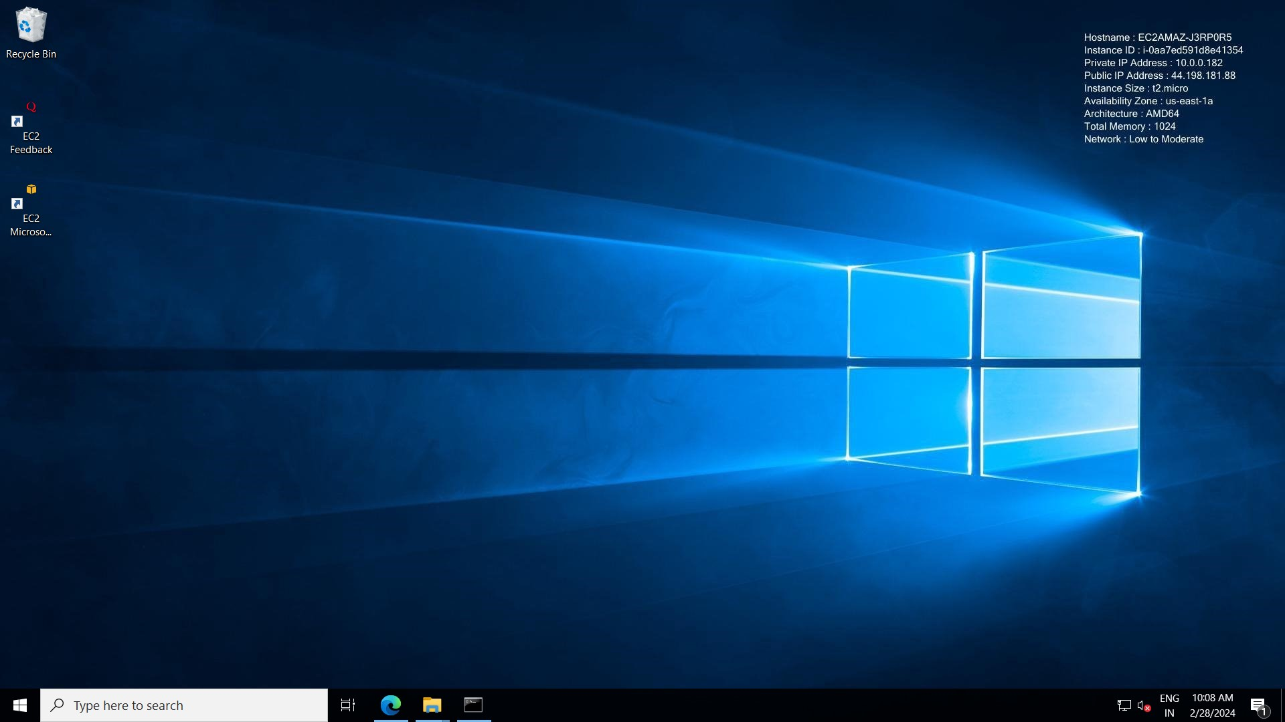

This is the Virtual Machine display.

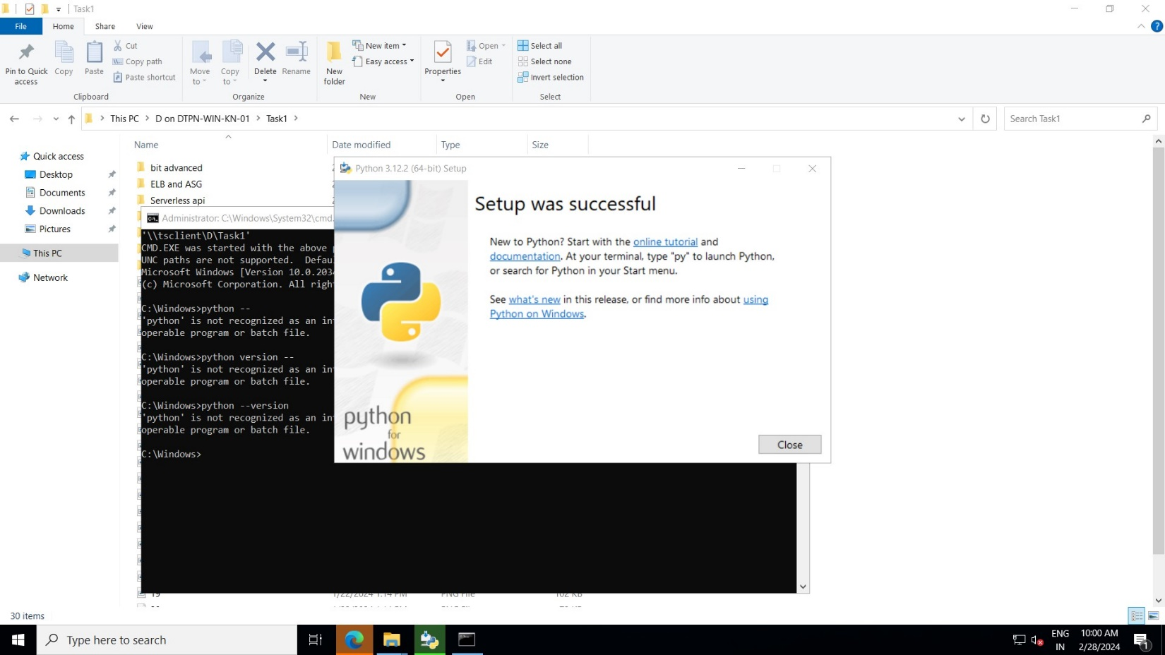

Install python in the same machine.

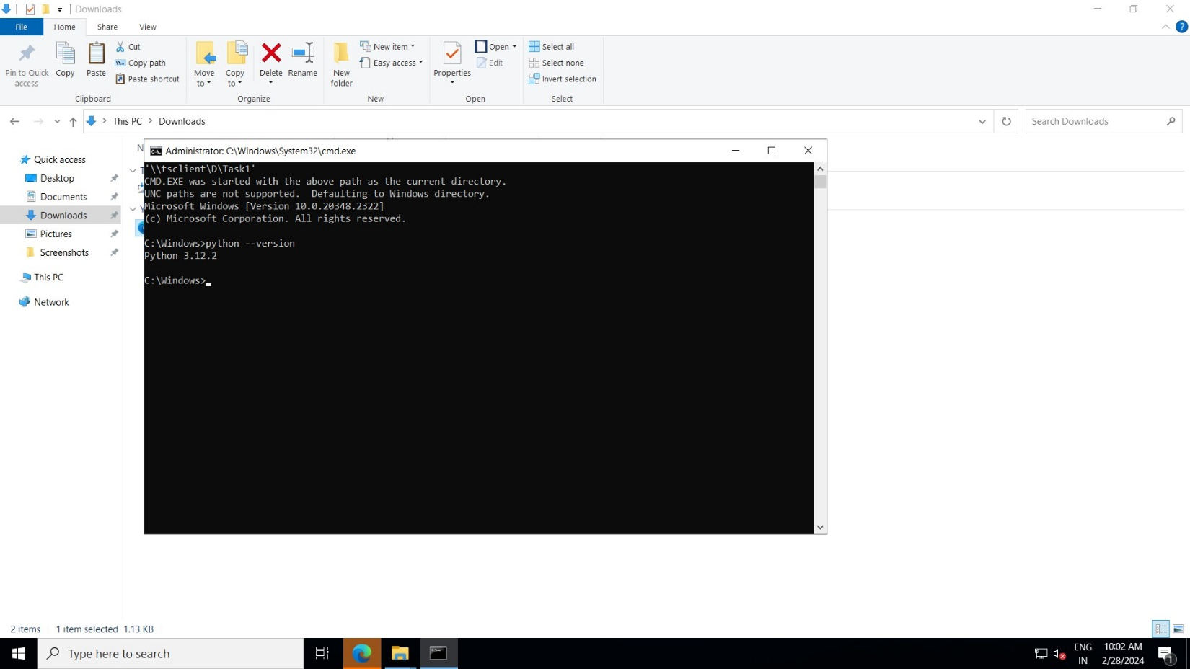

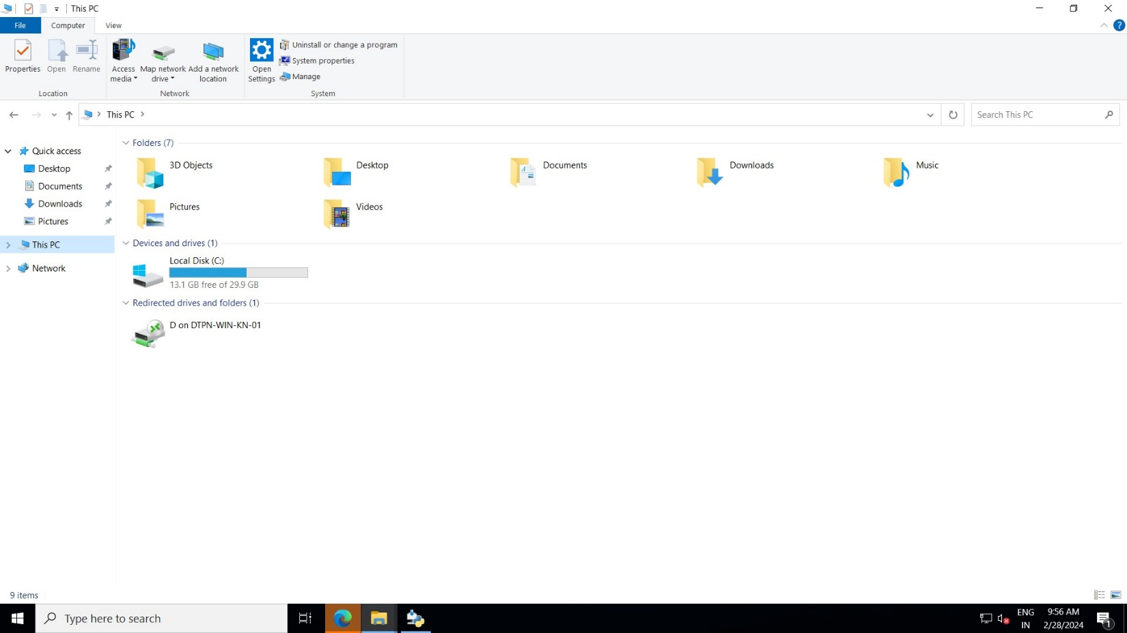

This is the shared drive(file system)

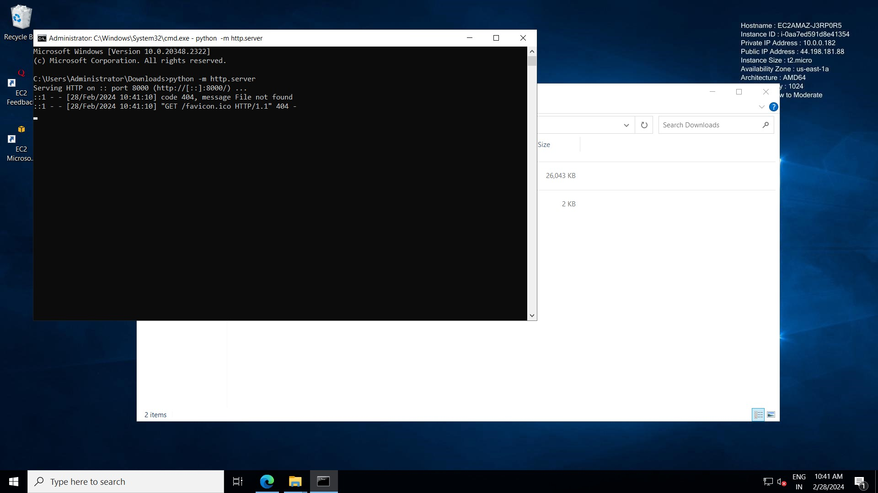

Give the above command in the location where your html profile file is saved. Below is desired output

Python -m http.server.

